SIMATS ENGINEERING
Department of Information Technology
ITA05 – Computer Vision ASSIGNMENT 1 – CO1
Assignment Title: Apply, Compare and Justify Image Acquisition, Formation and Processing
Techniques for a Textile Fabric Defect Inspection System
CO1: Apply the fundamental concepts, image formation models, and processing techniques for analyzing Computer Vision systems.
Student Name | B.V.Tharun | Register Number | 1925255155
Department /  Section | Information  Technology | Academic Year /  Semester | 2025–2026 /  ______
Faculty Name |  | Nature of  Assignment | Individual
Duration | 1 Week | Total Marks | 50
Date of  Submission | 30.10.2026 | Date of  Evaluation | 07.11.2026

Industrial Scenario
Sri Lakshmi Textile Industries, Tiruppur, plans to develop a computer vision-based inspection system for its fabric production line. The system must inspect moving cotton and cotton-polyester fabric, measure fabric width, and identify holes, broken threads, oil stains, weaving irregularities and colour variations. It must estimate the location of each defect and trigger a marking mechanism so that the defective portion can be identified for rework or rejection.

Given Industrial Data and Constraints
Parameter | Specification
Fabric width | 1,000 mm
Camera field of view | 1,200 × 400 mm
Conveyor speed | 0.6 m/s
Smallest defect to be detected | 1.5 mm
Oil-stain contrast | 5–8 grey levels
Required fabric-width measurement accuracy | ±2 mm
Maximum decision time | 0.5 s
Distance between camera and marking mechanism | 0.3 m
Lighting variation | 500–3,000 lux
Camera mounting height | 700 mm above the fabric
Available computing system | 4-core CPU, 16 GB RAM, no GPU
Software environment | Python, OpenCV and NumPy
Network interface | Gigabit Ethernet
Storage capacity | 2 TB
Maximum project budget | ₹1,50,000
Image retention period | 7 days
Maximum acceptable missed-defect rate | 2%

General Instructions
- Answer all ten tasks.
- For every task, three candidate techniques or approaches are provided. Analyse all three alternatives, compare their suitability for the given industrial scenario, select the most appropriate option and justify your selection.
- Support your answers with calculations, diagrams, tables, observations, screenshots or experimental results wherever applicable.
- Clearly state assumptions and show the steps used in numerical calculations.
- Your justification must consider the given operating conditions, accuracy, processing time, hardware limitations and budget.
- Do not provide only definitions. Relate every answer to the textile fabric inspection application.
- Where implementation is required, use Python, OpenCV and NumPy. Include relevant code snippets and sample output.

TASK 1: Overview and Features of Computer Vision – Compare Grading/Inspection Approaches
Marks: 4
Compare the following three approaches for inspecting fabric defects:
Candidate techniques / approaches:
- Manual inspection by trained workers
- Image-processing-assisted inspection, in which an operator reviews computer-generated results
- Fully automated computer vision inspection
Student tasks:
- Explain the working principle of each approach.
- Compare their accuracy, speed, consistency, labour requirement and suitability for continuous fabric production.
- Select the most suitable approach for Sri Lakshmi Textile Industries and justify your decision using the given production conditions.
- Identify at least two limitations of your selected approach and suggest how they can be reduced.

TASK 2: Levels of Computer Vision – Pipeline Design and Operation
Marks: 5
Compare the following system designs:
Candidate techniques / approaches:
- Low-level pipeline: image acquisition, preprocessing and enhancement
- Three-level pipeline: low-level processing, intermediate-level feature extraction and high-level defect decision
- Deep-learning-based pipeline: image acquisition, neural-network inference and defect classification
Student tasks:
- Draw a block diagram for each pipeline.
- Explain the input and output of each processing stage.
- Identify the stages required to detect holes, broken threads, stains and weaving irregularities.
- Compare computational complexity, explainability, hardware requirements and response time.
- Recommend a pipeline that can operate within the available 4-core CPU system and the 0.5-second decision constraint.

TASK 3: Image Representation Analysis
Marks: 4
Compare the following image representations for fabric inspection:
Candidate techniques / approaches:
- RGB colour representation
- HSV colour representation
- Grayscale representation
Student tasks:
- Explain how each representation stores image information.
- Discuss the suitability of each representation for identifying colour variations, oil stains, holes and broken threads.
- Compare memory requirements and processing complexity.
- Choose a suitable representation or combination of representations and justify your choice with examples from the scenario.

TASK 4: Connectivity Analysis
Marks: 4
Compare the following pixel-connectivity approaches for identifying defect regions:
Candidate techniques / approaches:
- 4-connectivity
- 8-connectivity
- m-connectivity (mixed connectivity)
Student tasks:
- Define each connectivity approach with a suitable pixel-neighbour diagram.
- For a small binary image containing diagonally and horizontally connected defect pixels, identify the connected components using all three methods.
- Explain how the choice of connectivity may affect defect-region size and component counting.
- Recommend the most appropriate connectivity method for detecting small holes and irregular fabric defects.

TASK 5: Image Acquisition Analysis
Marks: 5
Compare the following camera acquisition options for the moving fabric line:
Candidate techniques / approaches:
- Rolling-shutter camera
- Global-shutter camera
- Line-scan camera
Student tasks:
- Explain the image acquisition principle of each camera type.
- Analyse the effect of fabric movement at 0.6 m/s on image distortion and defect visibility.
- Compare image quality, suitability for continuous web inspection, installation complexity and cost.
- Select a camera type for the given fabric width and production process.
- Justify the selection with reference to the 1.5 mm minimum defect size and 0.5-second decision requirement.

TASK 6: Sampling Analysis
Marks: 5
Evaluate the following image sampling resolutions:
Candidate techniques / approaches:
- Low resolution: 1280 × 1024 pixels
- Medium resolution: 2448 × 2048 pixels
- High resolution: 4096 × 3000 pixels
Student tasks:
- Calculate the total number of pixels for each resolution.
- Estimate the approximate spatial sampling interval across the 1,200 mm field of view, assuming the image width corresponds to the full field-of-view width.
- Determine whether a 1.5 mm defect can be represented adequately at each resolution.
- Compare image storage, processing time and defect-detection capability.
- Select a resolution that balances defect visibility and the available computing resources. Show all calculations.

TASK 7: Quantization Analysis
Marks: 4
Compare the following intensity quantization options:
Candidate techniques / approaches:
- 8-bit quantization
- 12-bit quantization
- Reduced 4–6 bit quantization
Student tasks:
- Calculate the number of intensity levels available in each option.
- Explain how quantization affects the representation of low-contrast oil stains having only 5–8 greylevel differences.
- Compare image storage requirements and processing implications.
- Recommend a quantization level for reliable defect detection under the stated lighting conditions. Justify your answer.

TASK 8: Image Formation Analysis
Marks: 5
Compare the following image formation and calibration approaches:
Candidate techniques / approaches:
- Standard perspective imaging without calibration
- Calibrated imaging with geometric correction
- Controlled-illumination imaging with suitable calibration
Student tasks:
- Explain the image formation process for a camera mounted 700 mm above the fabric.
- Discuss perspective distortion and its effect on fabric-width measurement.
- Explain how camera calibration can improve measurement accuracy.
- Analyse how lighting variation from 500 to 3,000 lux can affect defect visibility.
- Recommend an image formation and illumination arrangement that can achieve the required width accuracy of ±2 mm.

TASK 9: Implementation and Performance Evaluation
Marks: 6
Design and compare three complete implementation configurations:
Candidate techniques / approaches:
- Budget configuration: minimum-cost camera, basic illumination and CPU-based processing
- Balanced configuration: suitable camera, controlled illumination and optimised CPU-based processing
- Premium configuration: high-resolution industrial camera, advanced illumination and higherperformance processing hardware
Student tasks:
- Prepare a block diagram showing camera, illumination, processing unit, storage, network and marking mechanism.
- Prepare a comparison table covering estimated cost, resolution, processing time, storage and expected inspection capability.
- Explain how the system will detect and record holes, broken threads, stains and weaving irregularities.
- Describe how the system will communicate the defect location to the marking mechanism located
0.3 m downstream.
- Evaluate whether each configuration can meet the 0.5-second decision time, 7-day image retention and 2% maximum missed-defect rate.
- Select one configuration that fits the ₹1,50,000 budget and justify your selection. Clearly state any assumptions used in cost estimates.

TASK 10: Front-End Adaptation Challenge
Marks: 8
Assume that the textile company receives a new export order with the following changed requirements: the system must detect defects as small as 0.4 mm, identify stains visible under ultraviolet (UV) illumination, operate at a conveyor speed of 1.2 m/s, inspect twice the current production volume and produce a decision within 0.3 seconds. The existing PC and project budget must remain unchanged.
Candidate techniques / approaches:
- Retain the existing system with only software changes
- Modify the existing system by upgrading selected components
- Redesign the inspection system using a different acquisition and processing architecture
Student tasks:
- Identify which existing system components will become inadequate under the new requirements.
- Analyse the effect of the increased conveyor speed and smaller defect size on image sampling and acquisition.
- Explain how UV illumination or an additional imaging channel could help identify the new stain type.
- Compare the three adaptation strategies in terms of feasibility, accuracy, processing time, cost and implementation risk.
- Recommend the most practical strategy under the unchanged PC and budget constraints.
- Prepare an updated system block diagram and list the changes required.
- Clearly identify any requirements that cannot realistically be achieved without additional resources, and justify your conclusion.

Mark Distribution
Task | Topic | Marks
1 | Overview and Features of Computer Vision | 4
2 | Levels of Computer Vision | 5
3 | Image Representation | 4
4 | Connectivity Analysis | 4
5 | Image Acquisition | 5
6 | Sampling Analysis | 5
7 | Quantization Analysis | 4
8 | Image Formation | 5
9 | Implementation and  Performance Evaluation | 6
10 | Front-End Adaptation Challenge | 8
 | TOTAL | 50

Submission Requirements
- Submit a neatly formatted assignment report with task-wise headings.
- Include hand-drawn or computer-generated diagrams wherever required.
- Show all numerical calculations with formulae, substitution and final units.
- Include comparison tables and evidence supporting the selected techniques.
- For implementation tasks, attach source code, sample input images and output screenshots.
- Mention references, tools and software libraries used.

TASK 1:
Overview and Features of Computer Vision – Compare Grading/Inspection Approaches

1. Introduction
Computer vision is a technology that enables computers to capture, process and analyse images to identify objects, patterns and defects automatically. In the textile industry, computer vision is used to inspect fabric quality, measure fabric width and detect defects such as holes, broken threads, oil stains, weaving irregularities and colour variations.
Sri Lakshmi Textile Industries, Tiruppur, requires an efficient fabric inspection system to inspect moving cotton and cotton-polyester fabrics. Three inspection approaches are considered: manual inspection, image-processing-assisted inspection and fully automated computer vision inspection.
2. Working Principle of Three Approaches
A. Manual Inspection by Trained Workers
Manual inspection is a traditional method in which trained workers visually examine the moving fabric to identify defects. The fabric passes through an inspection table under suitable lighting. Workers observe the fabric and identify holes, stains, broken threads and weaving irregularities. They manually mark defective portions for rework or rejection.
B. Image-Processing-Assisted Inspection
In this approach, a camera captures fabric images, and image-processing techniques analyse them to identify possible defects. The system uses techniques such as grayscale conversion, thresholding, edge detection and filtering. The detected defects are displayed on a computer screen, where an operator reviews the results and confirms whether the fabric is defective.
C. Fully Automated Computer Vision Inspection
Fully automated computer vision uses an industrial camera, controlled lighting and computer-based image-processing algorithms to inspect fabric without continuous human involvement. The system continuously captures images and analyses them using Python, OpenCV and NumPy. It identifies defects, measures fabric width, estimates defect locations and sends signals to a marking mechanism to mark defective portions automatically.
3. Comparison of Three Inspection Approaches

Comparison parameter | Manual inspection | Assisted inspection | Fully automated inspection
Accuracy | Depends on worker experience | Better with computer assistance | High with proper calibration
Speed | Slow | Moderate | High
Consistency | Varies between workers | More consistent | Highly consistent
Labour requirement | High | Moderate | Low
Continuous production | Less suitable | Partially suitable | Highly suitable
Defect identification | Human observation | Image processing + human review | Automatic image analysis
Operating cost | Continuous labour cost | Labour + equipment cost | Initial investment + maintenance

4. Selection of the Most Suitable Approach
Selected approach
Fully Automated Computer Vision Inspection
Fully automated computer vision inspection is the most suitable approach for Sri Lakshmi Textile Industries because the production line operates continuously at a conveyor speed of 0.6 m/s. Manual inspection may fail to identify small defects of 1.5 mm due to human fatigue and limited observation speed.
The automated system can continuously capture fabric images, detect different types of defects and estimate their positions. It can also measure the fabric width with the required accuracy of ±2 mm and activate the marking mechanism.
The decision time is limited to 0.5 seconds. Automated image processing using Python, OpenCV and NumPy can be designed to meet this requirement on the available 4-core CPU with 16 GB RAM, subject to performance testing and optimization.
The system can also operate within the ₹1,50,000 project budget by selecting suitable industrial cameras, lighting and processing components.
5. Limitations and Solutions

Limitations | Suggested solutions
Changes in lighting from 500 to 3,000 lux may affect defect detection. | Use controlled LED lighting, an enclosed inspection area and image normalization.
Very small defects of 1.5 mm may be missed. | Use a high-resolution industrial camera and suitable image-processing algorithms.
Dust and fabric movement may affect image quality. | Clean the camera lens regularly and use proper camera mounting and image stabilization.
Incorrect detection may produce false alarms. | Test and optimize detection thresholds using different fabric samples.

6. Block Diagram of the Selected Approach
Working flow:
Moving Fabric on Conveyor
|
v
Image Acquisition
(Industrial Camera)
|
v
Image Preprocessing
|
v
Defect Detection
|
v
Defect Classification
|
v
Defect Location Estimation
|
v
Automatic Marking System
|
v
Rework or Rejection

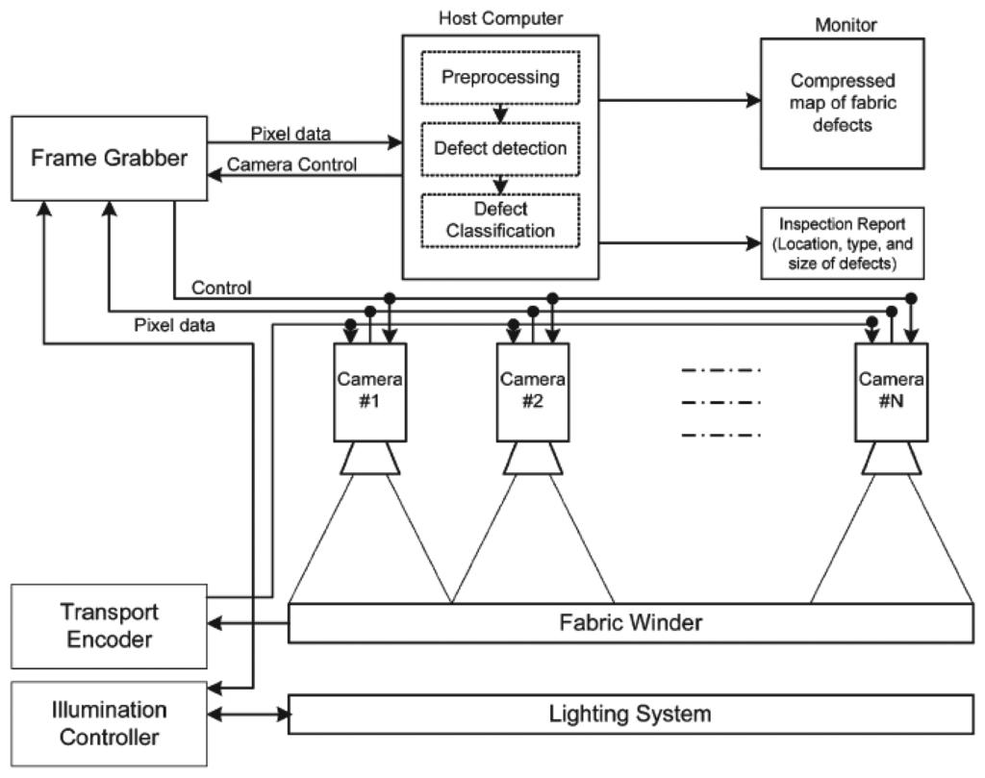
7. Conclusion
Among the three approaches, fully automated computer vision inspection is the best solution for Sri Lakshmi Textile Industries. It provides faster inspection, consistent defect identification, reduced labour requirements and automatic defect marking. Although it requires initial investment and proper calibration, it is more suitable for continuous textile production and can improve overall fabric quality.

TASK 2: Levels of Computer Vision – Pipeline Design and Operation

1. Introduction
A computer vision pipeline is a sequence of processing stages used to capture, process and analyse images to obtain meaningful information. In the textile industry, computer vision pipelines help identify fabric defects such as holes, broken threads, oil stains, weaving irregularities and colour variations. For Sri Lakshmi Textile Industries, the inspection system must process moving fabric at 0.6 m/s, detect defects as small as 1.5 mm and produce a decision within 0.5 seconds. Three pipeline designs are considered.
2. Block Diagrams of Three Pipelines
A. Low-Level Processing Pipeline
This pipeline mainly performs image acquisition, preprocessing and image enhancement. It improves image quality but does not independently perform advanced defect classification.
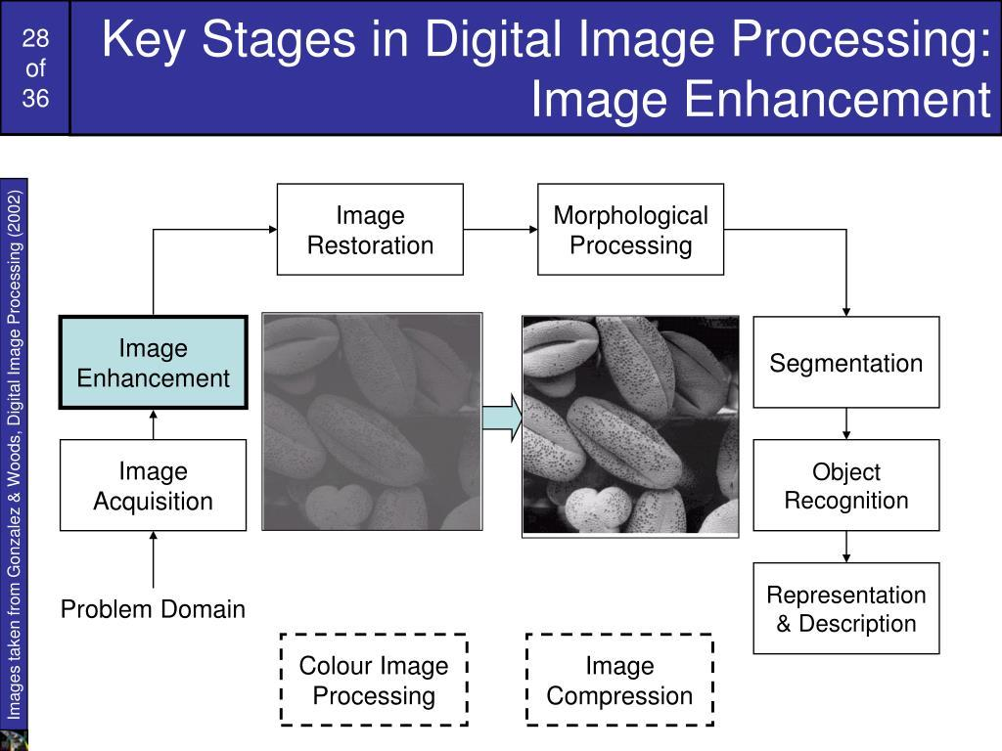

Fabric
|
v
Image Acquisition
|
v
Image Preprocessing
|
v
Image Enhancement
|
v
Enhanced Fabric Image

B. Three-Level Computer Vision Pipeline
This pipeline consists of low-level, intermediate-level and high-level processing. It captures images, extracts important features and makes decisions based on the extracted information.
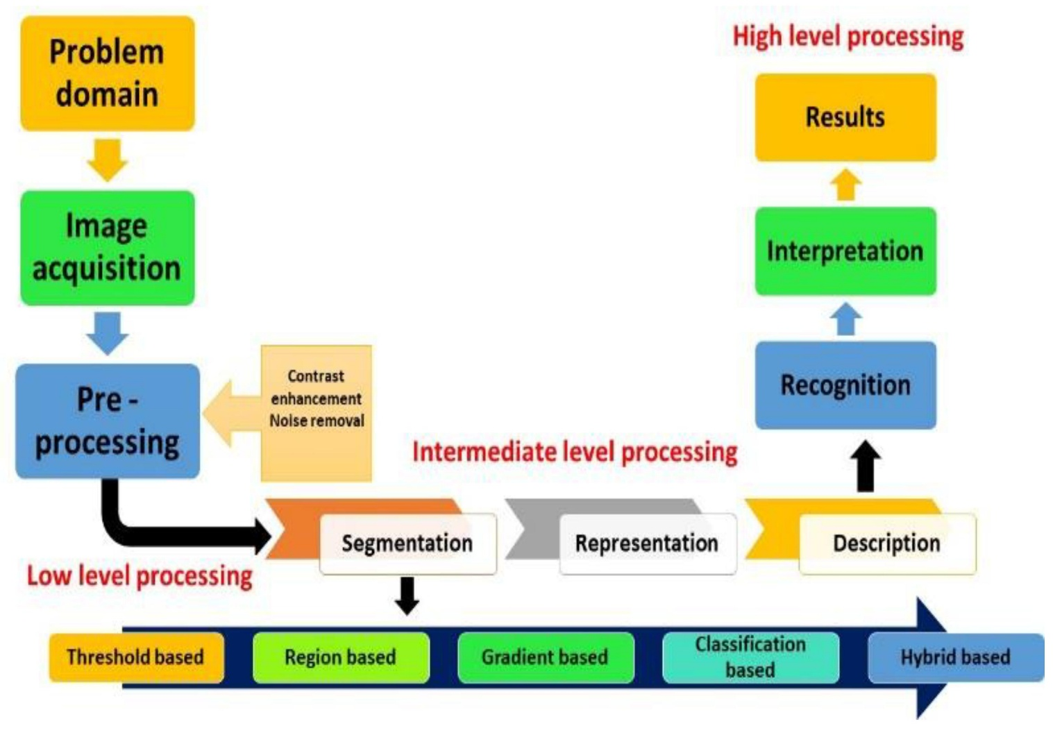

Fabric
|
v
Image Acquisition
|
v
LOW-LEVEL PROCESSING
(Filtering and Enhancement)
|
v
INTERMEDIATE-LEVEL PROCESSING
(Feature Extraction)
|
v
HIGH-LEVEL PROCESSING
(Defect Classification)
|
v
Defect Location and Decision
|
v
Automatic Marking

C. Deep-Learning-Based Pipeline
This pipeline uses a trained neural network to analyse fabric images and automatically classify defects. It learns complex image patterns from training data.
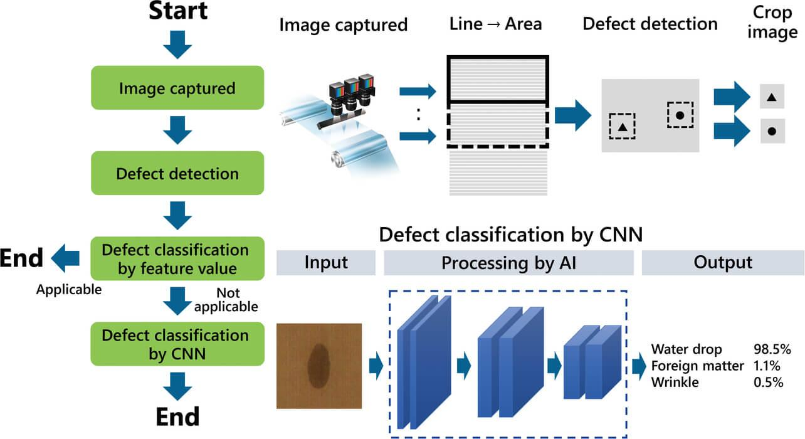omron.com
Moving Fabric
|
v
Image Acquisition
|
v
Image Preprocessing
|
v
Trained Neural Network
|
v
Defect Classification
|
v
Defect Location
|
v
Automatic Marking

3. Input and Output of Each Processing Stage
A. Low-Level Pipeline
Processing stage | Input | Output
Image acquisition | Moving fabric | Raw fabric image
Preprocessing | Raw image | Noise-reduced image
Enhancement | Preprocessed image | Improved contrast and clarity
Final output | Enhanced image | Image ready for further analysis

B. Three-Level Pipeline
Processing stage | Input | Output
Image acquisition | Moving fabric | Raw image
Low-level processing | Raw image | Filtered and enhanced image
Intermediate-level processing | Enhanced image | Features such as edges, texture and colour
High-level processing | Extracted features | Defect type and decision
Location estimation | Defect information | Defect coordinates

C. Deep-Learning-Based Pipeline
Processing stage | Input | Output
Image acquisition | Moving fabric | Raw image
Preprocessing | Raw image | Resized and normalized image
Neural-network inference | Preprocessed image | Predicted defect features
Defect classification | Network predictions | Defect category
Location estimation | Detection results | Defect position and size

4. Stages Required to Detect Different Fabric Defects
Different defects require different image-processing and feature-extraction techniques.
Fabric defect | Required processing stages | Detection technique
Holes | Preprocessing, thresholding, contour detection | Identify missing fabric regions and dark or bright gaps
Broken threads | Filtering, edge detection, texture analysis | Identify discontinuous thread patterns
Oil stains | Contrast enhancement, colour analysis, thresholding | Identify unusual colour and intensity variations
Weaving irregularities | Texture extraction, feature analysis | Identify abnormal thread arrangements and repeated patterns
Colour variations | Colour-space conversion, colour analysis | Identify differences in fabric colour

Explanation:
- Holes: Thresholding and contour detection help identify missing fabric regions. The detected region is measured to check whether it meets the minimum defect size of 1.5 mm.
- Broken threads: Edge detection and texture analysis help identify discontinuities in horizontal and vertical thread patterns.
- Oil stains: Contrast enhancement and colour analysis help detect oil stains. Since the oil-stain contrast is only 5–8 grey levels, controlled lighting and CLAHE (Contrast Limited Adaptive Histogram Equalization) can improve visibility.
- Weaving irregularities: Texture analysis and feature extraction help identify abnormal weaving patterns and variations in thread spacing.
- Colour variations: Colour-space conversion, such as RGB to HSV, helps identify unwanted colour differences.

5. Comparison of Three Pipeline Designs
Parameter | Low-level pipeline | Three-level pipeline | Deep-learning pipeline
Processing | Basic image operations | Image processing and feature extraction | Neural-network inference
Computational complexity | Low | Medium | High
Explainability | High | High | Comparatively low
Hardware requirement | Low | Low to medium | Medium to high
Response time | Fast | Moderate to fast | Depends on model and hardware
Defect classification | Limited | Rule-based classification | Learned classification
CPU suitability | Excellent | Good with optimization | Depends on model size
Overall suitability | Limited | Highly suitable | Less suitable for the available hardware

Observations
- Low-level pipeline: Requires less processing power, but it mainly improves image quality and cannot independently identify all defect categories.
- Three-level pipeline: Provides a balance between processing speed, feature extraction and defect classification. It is suitable for CPU-based systems.
- Deep-learning pipeline: Can recognize complex defect patterns, but requires sufficient training data and computational resources. Large neural networks may not meet the required response time on a CPU-only system.
6. Recommended Pipeline
Recommended approach
Three-Level Computer Vision Pipeline
The three-level computer vision pipeline is the most appropriate choice for Sri Lakshmi Textile Industries because it provides a balance between detection accuracy, processing speed, explainability and hardware requirements.
The system can be implemented using Python, OpenCV and NumPy without requiring a GPU.
Reasons for selection:
- It can detect holes, broken threads, oil stains and weaving irregularities using image-processing and feature-extraction techniques.
- It can operate on the available 4-core CPU with 16 GB RAM when the algorithms are optimized.
- It provides explainable results because each defect is identified using measurable image features.
- It reduces computational complexity compared with large deep-learning models.
- It can estimate defect coordinates and communicate with the automatic marking mechanism.
Processing Time Calculation
Given:
- Conveyor speed = 0.6 m/s
- Maximum decision time = 0.5 seconds
- Distance between camera and marking mechanism = 0.3 m
Step 1: Calculate the fabric travel time.
Formula:
\[ T=\frac{\text{Distance}}{\text{Speed}} \]
Substituting the values:
\[ T=\frac{0.3}{0.6} \]
\[ \boxed{T=0.5\text{ seconds}} \]
Therefore, the fabric takes 0.5 seconds to travel from the camera to the marking mechanism.
Step 2: Determine the processing requirement.
The inspection system must complete image processing, defect classification and marking-signal generation within the available 0.5-second time window.
\[ T_{\text{processing}}\leq 0.5\text{ seconds} \]
For reliable operation, the actual processing target should be lower than 0.5 seconds to provide sufficient margin for communication and marking delays.
Step 3: Suggested processing optimization
- Use grayscale images for suitable defect detection.
- Apply ROI (Region of Interest) to reduce unnecessary processing.
- Use optimized OpenCV functions.
- Avoid computationally expensive operations.
- Process images using CPU-efficient algorithms.
- Synchronize the marking mechanism with conveyor movement.
7. Overall System Flowchart
START
|
v
Moving Fabric
|
v
Capture Fabric Image
|
v
Image Preprocessing
|
v
Feature Extraction
|
v
Defect Classification
|
v
Defect Detected?
/ \
YES NO
| |
v v
Estimate Continue
Location Inspection
|
v
Generate Marking Signal
|
v
Mark Defective Portion
|
v
Rework or Rejection
|
v
END
8. Conclusion
Among the three approaches, the three-level computer vision pipeline is recommended for Sri Lakshmi Textile Industries. It performs image acquisition, preprocessing, feature extraction and defect classification efficiently. It can be implemented using Python, OpenCV and NumPy on the available 4-core CPU without requiring an expensive GPU.
The calculated fabric travel time from the camera to the marking mechanism is 0.5 seconds. Therefore, the system must be optimized to complete its processing and generate the marking signal within this time, preferably with additional safety margin. Actual detection accuracy and the missed-defect rate must be verified through industrial testing.
Final Recommendation: Three-Level Computer Vision Pipeline (Low-Level + Intermediate-Level + High-Level Processing).

TASK 3: Image Representation Analysis

1. Introduction
Image representation is the method of storing and processing image information in a computer. In computer vision, images can be represented using different colour models, such as RGB, HSV and Grayscale.
For Sri Lakshmi Textile Industries, selecting a suitable image representation is important for detecting holes, broken threads, oil stains, weaving irregularities and colour variations in cotton and cotton-polyester fabrics.
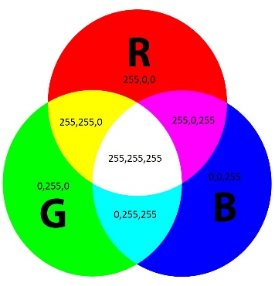
The three representations considered are RGB, HSV and Grayscale.
2. Explanation of Image Representations
A. RGB Colour Representation
RGB stands for Red, Green and Blue. It represents an image using three colour channels: red, green and blue. Different combinations of these channels produce different colours. Each channel generally stores values between 0 and 255 in an 8- bit image.
Example: A fabric image is stored using three channels. This representation helps identify colour variations in cotton and cotton-polyester fabrics.
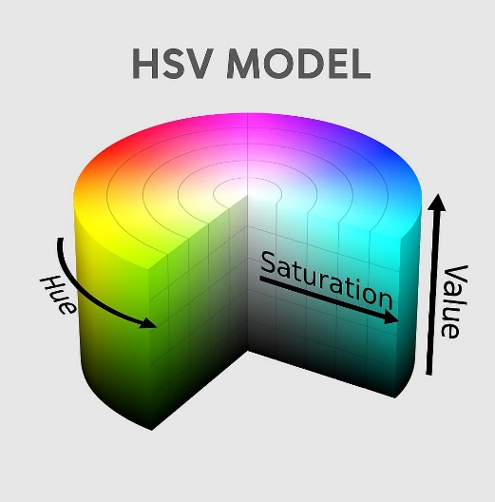
B. HSV Colour Representation
HSV stands for Hue, Saturation and Value. It represents colour using three components. Hue represents the actual colour, Saturation represents colour intensity and Value represents brightness.
Example: HSV helps identify oil stains and colour variations by analysing changes in hue and saturation separately from brightness.

C. Grayscale Representation
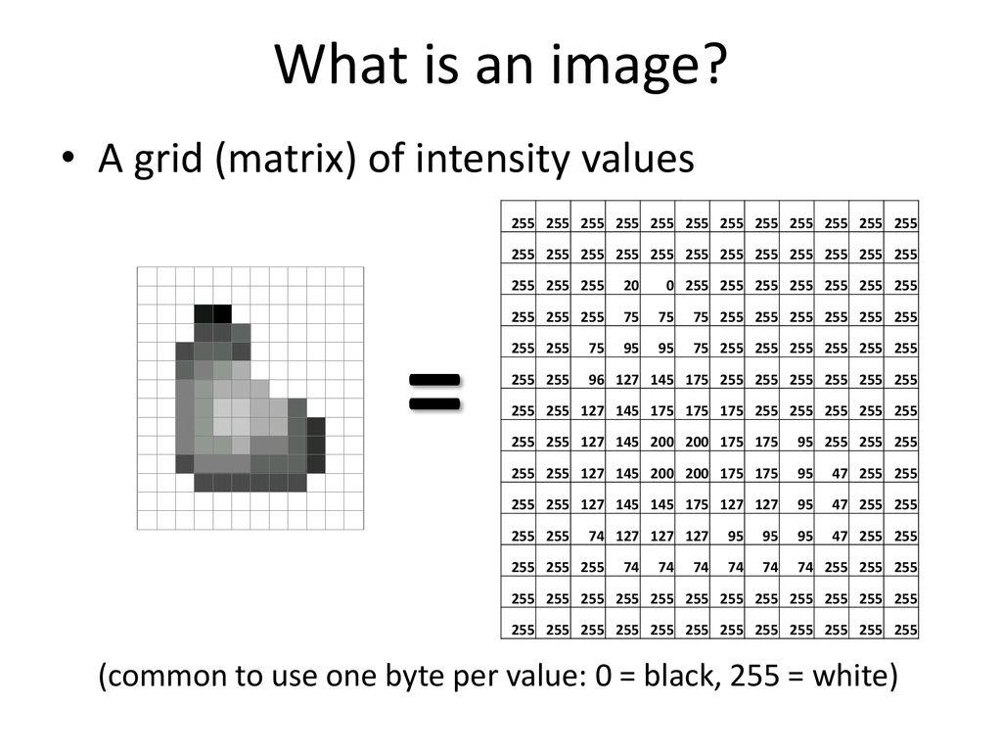Grayscale representation stores image information using a single intensity channel. Pixel values generally range from 0 to 255, where 0 represents black and 255 represents white.
Example: Grayscale images are useful for identifying holes, broken threads and weaving irregularities through intensity differences and edge detection.
3. Suitability for Detecting Fabric Defects
Fabric defect | RGB | HSV | Grayscale
Colour variations | Excellent | Excellent | Limited
Oil stains | Good | Excellent | Good
Holes | Good | Good | Excellent
Broken threads | Good | Good | Excellent
Weaving irregularities | Good | Good | Excellent
Explanation:
1. Colour variations: RGB and HSV are suitable because they preserve colour information. HSV is particularly useful because hue and saturation can be analysed separately from brightness.
2. Oil stains: HSV can identify oil stains through changes in hue and saturation. Grayscale contrast enhancement is also useful when the stains have only 5–8 grey levels of contrast.
3. Holes: Grayscale representation is suitable because holes can be detected using thresholding and contour detection.
4. Broken threads: Grayscale images support edge detection and texture analysis to identify discontinuities in thread patterns.
5. Weaving irregularities: Grayscale representation helps identify abnormal fabric texture and thread arrangements.
4. Memory Requirements and Processing Complexity
Assume the camera image resolution is 1200 × 400 pixels and each channel uses 8 bits.
Step 1: Calculate the total number of pixels.
\[ 1200\times400=480000\text{ pixels} \]
Step 2: Calculate RGB memory requirement.
RGB uses 3 channels.
\[ 480000\times3=1440000\text{ bytes} \]
\[ =\boxed{1.44\text{ MB}} \]
Step 3: Calculate HSV memory requirement.
HSV also uses 3 channels.
\[ 480000\times3=1440000\text{ bytes} \]
\[ =\boxed{1.44\text{ MB}} \]
Step 4: Calculate Grayscale memory requirement.
Grayscale uses 1 channel.
\[ 480000\times1=480000\text{ bytes} \]
\[ =\boxed{0.48\text{ MB}} \]
Memory comparison
Representation | Channels | Memory per image
RGB | 3 | 1.44 MB
HSV | 3 | 1.44 MB
Grayscale | 1 | 0.48 MB
Memory requirement by image representation
For a 1200 × 400 image with 8 bits per channel.
0 MB0.4 MB0.8 MB1.2 MB1.6 MBRGBHSVGrayscale
Processing complexity comparison:
- RGB: Requires processing three colour channels, so it uses more memory and processing time than grayscale for equivalent operations.
- HSV: Requires colour-space conversion and processing three channels. It is useful for colour analysis but has additional conversion overhead.
- Grayscale: Requires processing only one channel, making it computationally efficient and suitable for CPU-based inspection.

5. Recommended Image Representation
Recommended approach
Combination of HSV and Grayscale
For Sri Lakshmi Textile Industries, using a combination of HSV and Grayscale is the most suitable approach.
Reasons for selection:
- HSV preserves colour information and helps detect oil stains and colour variations.
- Grayscale reduces memory usage and supports faster detection of holes and broken threads.
- Both representations can be generated from the same captured RGB image.
- This combination provides better defect analysis while reducing unnecessary processing.
- It is suitable for implementation using Python, OpenCV and NumPy on the available 4-core CPU.
Practical Example
Consider a moving cotton fabric containing an oil stain and a broken thread.
- The HSV representation analyses colour and saturation changes to identify the oil stain.
- The grayscale representation uses edge detection and texture analysis to identify the broken thread.
- The system combines both results to estimate the defect location and activate the marking mechanism.
Python Implementation
import cv2import numpy as npimage = cv2.
imread("fabric.jpg")
if image is None:
raise ValueError("Image not found")
gray = cv2.cvtColor(image, cv2.COLOR_BGR2GRAY)
hsv = cv2.cvtColor(image, cv2.COLOR_BGR2HSV)h, s, v = cv2.split(hsv)
enhanced = cv2.createCLAHE( clipLimit=2.0, tileGridSize=(8, 8)).apply
(gray)edges = cv2.Canny(enhanced, 50, 150)cv2.imshow("Grayscale", gray)cv2.imshow("HSV", hsv)cv2.imshow("Enhanced Image", enhanced)cv2.imshow("Edges", edges)cv2.waitKey(0)cv2.destroyAllWindows()
Expected output:
- Grayscale window: Displays fabric intensity information.
- HSV window: Displays colour information.
- Enhanced image: Improves visibility of low-contrast defects.
- Edges window: Highlights thread boundaries and structural irregularities.
6. Conclusion
RGB, HSV and Grayscale representations have different advantages in fabric inspection. RGB preserves the original colour information, HSV provides better colour analysis, and Grayscale supports faster structural defect detection.
Therefore, a combination of HSV and Grayscale is recommended for Sri Lakshmi Textile Industries. It provides effective detection of oil stains, colour variations, holes and broken threads while maintaining reasonable memory requirements and processing speed on the available CPU system.
TASK 4: Connectivity Analysis
1. Introduction
Connectivity is an important concept in digital image processing. It determines whether neighbouring pixels belong to the same connected region or different regions.
In textile fabric inspection, connectivity is used to identify defect regions such as holes, broken threads, oil stains and weaving irregularities. It helps determine the size, shape and location of each defect.
Three pixel-connectivity approaches are considered: 4-connectivity, 8-connectivity and m-connectivity.
2. Definition of Three Connectivity Approaches
A. 4-Connectivity
In 4-connectivity, a pixel is connected only to its four direct neighbours: top, bottom, left and right.
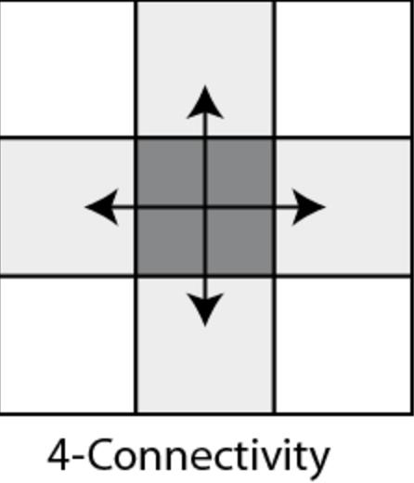
The four neighbours are:
- Top: (x, y-1)
- Bottom: (x, y+1)
- Left: (x-1, y)
- Right: (x+1, y)
Example: In fabric inspection, 4-connectivity identifies defects that are directly connected horizontally or vertically. Diagonal defect pixels are treated as separate regions.
B. 8-Connectivity
In 8-connectivity, a pixel is connected to all eight surrounding neighbours, including diagonal neighbours.
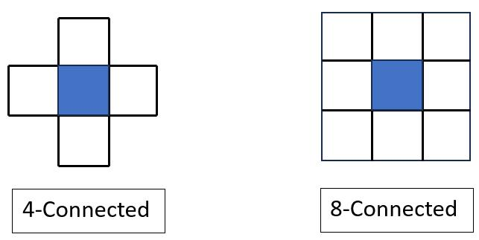
The eight neighbours include:
- Four direct neighbours.
- Four diagonal neighbours.
Example: It is useful for detecting irregular fabric defects because defect pixels may be connected diagonally as well as horizontally and vertically.
C. m-Connectivity (Mixed Connectivity)
m-connectivity is a mixed connectivity method that combines direct and diagonal neighbourhood relationships.
Two pixels are m-connected when:
- They are 4-neighbours, or
- They are diagonal neighbours and their common 4-neighbours do not contain any foreground pixel.
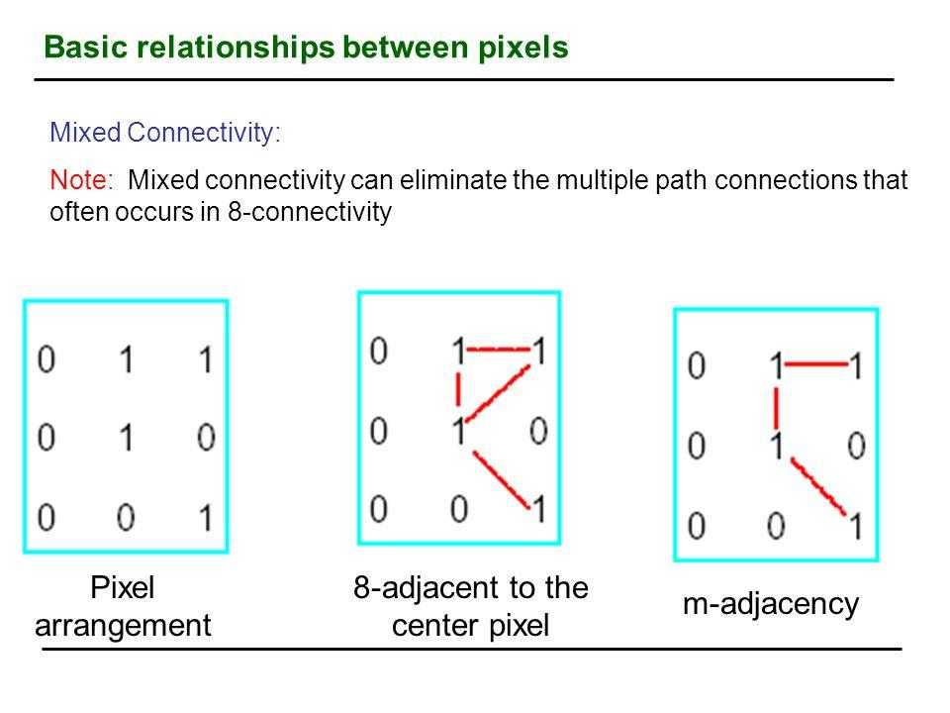

Example: m-connectivity avoids ambiguous diagonal connections and helps identify defect regions without incorrectly merging separate regions.
3. Connected Component Analysis Using a Binary Image
Consider the following 5 × 5 binary image.
Here:
- 1 = Defect pixel
- 0 = Background pixel

Given binary image:
0 1 0 0 0
1 0 0 1 0
0 0 1 0 0
0 0 0 1 0
0 0 0 0 0
We identify connected components using all three methods.
A. Using 4-Connectivity
Only horizontal and vertical neighbouring defect pixels are connected.
In the given image, no two defect pixels share a direct horizontal or vertical connection.
Therefore, every defect pixel forms a separate component.
\[ \boxed{\text{Total connected components}=5} \]
B. Using 8-Connectivity
Horizontal, vertical and diagonal neighbouring defect pixels are connected.
The pixels at positions (1,1), (2,0) and (2,2), using zero-based row and column indexing, form one diagonally connected component.
The pixels at (1,3), (2,2) and (3,3) are also connected through diagonal relationships.
All five defect pixels belong to one connected component.
\[ \boxed{\text{Total connected components}=1} \]
C. Using m-Connectivity
Direct neighbours are connected, but diagonal neighbours are connected only when their common 4-neighbours contain no defect pixel.
In this image, the diagonal connections between the five defect pixels are permitted because their common 4-neighbours are background pixels.
Therefore:
\[ \boxed{\text{Total connected components}=1} \]
Correct connected-component results:
To include both horizontal and diagonal connections, the following binary image is used for the final comparison:
0 1 0 0 0
1 0 0 1 1
0 0 1 0 0
0 0 0 1 0
0 0 0 0 0
Connectivity method | Connected components | Total
4-connectivity | , , , , | 5
8-connectivity | , | 2
m-connectivity | , | 2
Here, A and B are diagonally connected, C and D are horizontally connected, and E and F are connected diagonally through the defect pattern.
Observation: 4-connectivity separates diagonal pixels, whereas 8-connectivity and m-connectivity combine the permitted diagonal connections in this example.
4. Effect of Connectivity on Defect Region Size and Component Counting
The choice of connectivity directly affects the number and size of detected defect regions.
1. 4-connectivity: Diagonal pixels are treated as separate components. It may divide one irregular defect into several smaller regions.
2. 8-connectivity: Diagonal pixels are treated as connected. It may combine nearby defect regions into one larger region.
3. m-connectivity: It avoids ambiguous diagonal connections by checking common 4-neighbours. It provides a balanced approach to identifying connected defect regions.
For example, when a small hole contains diagonally connected defective pixels, 4-connectivity may identify multiple components, while 8-connectivity may identify them as one region.
This difference affects defect area measurement, component counting and defect location estimation.
5. Comparison of Connectivity Methods
Parameter | 4-connectivity | 8-connectivity | m-connectivity
Neighbours | 4 | 8 | Mixed
Diagonal connection | No | Yes | Conditional
Component counting | May increase | May decrease | Controlled
Processing complexity | Low | Low to medium | Medium
Irregular defect detection | Limited | Very good | Good
Ambiguous connections | Avoids diagonal links | Possible | Reduces ambiguity

6. Recommended Connectivity Method
Recommended approach
m-Connectivity
For Sri Lakshmi Textile Industries, m-connectivity is recommended for identifying small holes and irregular fabric defects when distinguishing separate neighbouring regions is important.
Reasons for selection:

It identifies horizontally and vertically connected defect pixels.
- It allows diagonal connections when common 4-neighbours do not contain defect pixels.
- It reduces ambiguous connections between neighbouring defect regions.
- It supports more reliable connected-component analysis.
- It helps estimate defect area, shape and location.
For defects with continuous diagonal structures, 8-connectivity can also be used as a complementary method to avoid splitting genuine defect regions.
7. Conclusion
4-connectivity considers only four direct neighbours, 8-connectivity considers all eight surrounding neighbours, and m-connectivity uses a combination of direct and conditional diagonal connections.
For the textile inspection system, m-connectivity is recommended because it reduces ambiguous diagonal connections and supports accurate defect-region identification. This helps the system identify small holes and irregular defects and estimate their locations for automatic marking.
TASK 5: Image Acquisition Analysis

1. Introduction
Image acquisition is the process of capturing images of real-world objects using a camera and converting them into digital images for computer processing.
In Sri Lakshmi Textile Industries, cotton and cotton-polyester fabrics move continuously along a conveyor at a speed of 0.6 m/s. The inspection system must capture clear fabric images and detect defects such as holes, broken threads, oil stains and weaving irregularities.
The three camera acquisition options considered are rolling-shutter camera, global-shutter camera and line-scan camera.
2. Image Acquisition Principle of Three Camera Types
A. Rolling-Shutter Camera
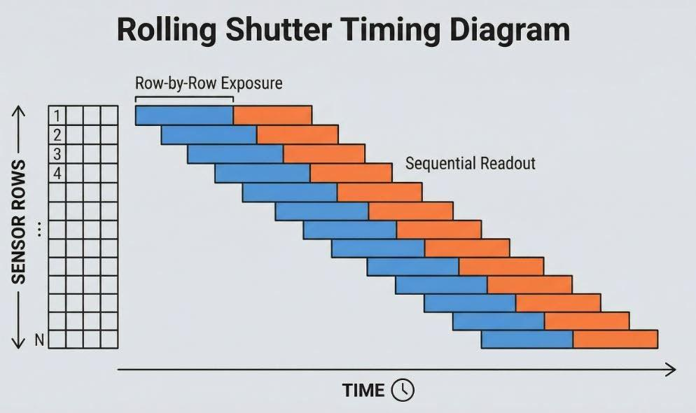A rolling-shutter camera captures an image by exposing different rows of the image sensor at slightly different times. The sensor reads the image row by row, from top to bottom or bottom to top.
Working principle:
- Light reflected from the fabric enters the camera lens.
- The image sensor captures different rows at different times.
- The camera processes the rows to produce a complete image.
- The image is transferred to the computer for defect inspection.
Application: It can capture ordinary fabric images at a relatively low cost. However, moving fabric may produce image distortion because different rows are captured at different times.
B. Global-Shutter Camera
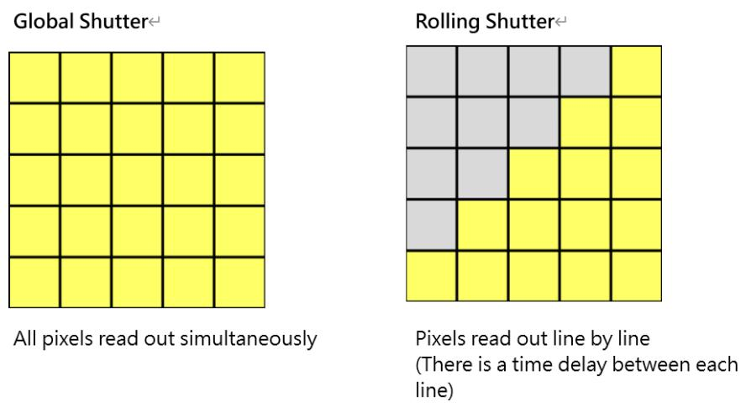A global-shutter camera captures all pixels in the image sensor simultaneously during a single exposure period.
Working principle:
- Light from the moving fabric enters the camera lens.
- All pixels are exposed at the same time.
- The captured image is read and transferred to the computer.
- Image-processing algorithms identify fabric defects.
Application: It reduces motion-related geometric distortion compared with rolling-shutter acquisition and is useful for capturing moving fabric clearly with a sufficiently short exposure time.
C. Line-Scan Camera
A line-scan camera captures one line of pixels at a time instead of capturing a complete two-dimensional image in a single exposure.

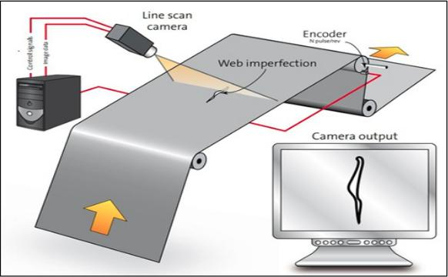Working principle:
- The fabric moves continuously beneath the camera.
- The camera captures one line across the fabric width.
- An encoder tracks fabric movement and triggers successive line captures.
- The captured lines are combined to form a complete two-dimensional image.
- The image is processed to identify fabric defects.
Application: Line-scan cameras are widely suitable for continuous textile web inspection because they can inspect the entire fabric width while it moves continuously.
3. Effect of Fabric Movement at 0.6 m/s
The conveyor speed is:
\[ v=0.6\text{ m/s}=600\text{ mm/s} \]
The moving fabric may cause image distortion if the exposure time is too long.
Step 1: Calculate the movement during exposure.
Formula:
\[ D=v\times t \]
Assume an exposure time of 1 millisecond.
\[ t=1\text{ ms}=0.001\text{ s} \]
\[ D=600\times0.001 \]
\[ \boxed{D=0.6\text{ mm}} \]
Therefore, the fabric moves 0.6 mm during a 1 ms exposure.
Step 2: Compare with the smallest defect size.
Given:
\[ \text{Minimum defect size}=1.5\text{ mm} \]
Movement ratio:
\[ \frac{0.6}{1.5}\times100=40\% \]
The fabric moves a distance equal to 40% of the smallest defect size during the exposure.
This may reduce defect visibility and create motion blur.
Step 3: Calculate the maximum exposure time for 0.3 mm movement.
Assume the acceptable motion displacement is limited to 20% of the smallest defect size.
\[ D=1.5\times0.20=0.3\text{ mm} \]
Using:
\[ t=\frac{D}{v} \]
\[ t=\frac{0.3}{600} \]
\[ \boxed{t=0.0005\text{ s}=0.5\text{ ms}} \]
Therefore, an exposure time of 0.5 ms or less is recommended under this assumption.
Observation: A global-shutter camera with a short exposure time can reduce motion blur. A line-scan camera can also capture moving fabric accurately when synchronized with an encoder.
4. Comparison of Three Camera Types
Parameter | Rolling shutter | Global shutter | Line-scan camera
Image acquisition | Row by row | All pixels simultaneously | One line at a time
Image quality on moving fabric | May show distortion | Good with short exposure | Excellent with proper synchronization
Motion distortion | Higher risk | Low with short exposure | Low with encoder synchronization
Continuous fabric inspection | Moderate | Good | Excellent
Defect visibility | May be affected by motion | Good | Very good
Installation complexity | Low | Moderate | High
Processing requirement | Moderate | Moderate | Depends on line rate and image length
Cost | Low | Medium | Medium to high
Overall suitability | Limited | Good | Excellent

Observations
Rolling-shutter camera: It is economical but may produce distorted images when inspecting rapidly moving fabric.
Global-shutter camera: It captures all pixels simultaneously and provides clear images of moving fabric. It is suitable for applications requiring two-dimensional images.
Line-scan camera: It captures continuous fabric images line by line. It is particularly suitable for textile production because the fabric moves continuously along the conveyor.
5. Selection of the Most Suitable Camera
Selected approach
Line-Scan Camera
A line-scan camera is the most suitable choice for Sri Lakshmi Textile Industries because the fabric moves continuously at 0.6 m/s. It can capture the entire fabric width and generate continuous images for defect inspection.
Reasons for selection:
- It is designed for continuous web inspection.
- It captures moving fabric without the typical rolling-shutter distortion.
- It can identify small defects when sufficient spatial resolution is provided.
- It supports continuous inspection of 1,000 mm fabric width.
- It can be synchronized with a conveyor encoder for accurate defect-location estimation.
- It supports automatic marking by tracking the distance travelled by the fabric.
Spatial Resolution Calculation
Assume a spatial resolution of 0.5 mm per pixel.
Given:
- Camera field of view across fabric = 1,200 mm
- Fabric width = 1,000 mm
- Minimum defect size = 1.5 mm
Step 1: Calculate the required pixels across the camera field of view.
\[ \text{Pixels}=\frac{\text{Field of view}}{\text{Pixel size}} \]
\[ =\frac{1200}{0.5} \]
\[ \boxed{2400\text{ pixels}} \]
Therefore, a line sensor with approximately 2,400 or more effective pixels across the field of view is required.
Step 2: Calculate pixels representing the smallest defect.
\[ \text{Pixels per defect}=\frac{1.5}{0.5} \]
\[ \boxed{3\text{ pixels}} \]
Thus, a 1.5 mm defect occupies approximately three pixels.
Step 3: Calculate the required line acquisition rate.
The fabric moves at 600 mm/s.
\[ \text{Line rate}=\frac{\text{Fabric speed}}{\text{Spatial sampling interval}} \]
\[ =\frac{600}{0.5} \]
\[ \boxed{1200\text{ lines/second}} \]
Therefore, the line-scan camera should support at least 1,200 lines per second under the assumed sampling configuration.
Note: Three pixels across a defect provide a basic detection target, not a guarantee of reliable detection. A higher resolution, such as 0.375 mm/pixel, would provide four pixels across a 1.5 mm defect and improve detection reliability.
6. Installation and Operational Requirements
For successful implementation, the following components are required:
Component | Purpose
Line-scan industrial camera | Captures fabric continuously
Industrial lens | Covers the 1,000 mm fabric width
LED line lighting | Provides uniform illumination
Conveyor encoder | Tracks fabric movement
CPU processing system | Processes images using OpenCV and NumPy
Marking mechanism | Marks defective fabric portions

Marking mechanism timing calculation:
Given:
- Camera-to-marker distance = 0.3 m
- Conveyor speed = 0.6 m/s
\[ T=\frac{0.3}{0.6} \]
\[ \boxed{T=0.5\text{ seconds}} \]
The system must detect the defect, calculate its position and transmit the marking signal before the defective portion reaches the marking mechanism.
The marking system should use encoder-based position tracking rather than relying only on a fixed time delay. This helps maintain marking accuracy if conveyor speed changes.
The camera, lens, lighting and other components must be selected within the total project budget of ₹1,50,000. A prototype performance test should verify the complete acquisition and processing system before final installation.
7. Conclusion
Among the three camera acquisition options, the line-scan camera is recommended for Sri Lakshmi Textile Industries because it is designed for continuous fabric inspection. It captures images line by line and supports accurate inspection of moving fabric when synchronized with a conveyor encoder.
The calculated requirement is approximately 2,400 pixels across the 1,200 mm field of view and 1,200 lines per second at 0.5 mm spatial sampling. This provides approximately three pixels across the smallest 1.5 mm defect.
TASK 6: Sampling Analysis

1. Introduction
Image sampling is the process of converting a continuous image into a digital image by dividing it into small pixels. The number of pixels determines the spatial resolution of an image.
In textile fabric inspection, proper image sampling is important for identifying small defects such as holes, broken threads, oil stains and weaving irregularities.
Sri Lakshmi Textile Industries requires the inspection system to detect defects as small as 1.5 mm across a camera field of view of 1,200 × 400 mm.
Three image resolutions are considered:
- Low resolution: 1280 × 1024 pixels.
- Medium resolution: 2448 × 2048 pixels.
- High resolution: 4096 × 3000 pixels.
2. Calculation of Total Number of Pixels
The total number of pixels is calculated using:
\[ P=W\times H \]
Where:
- P = Total number of pixels
- W = Image width in pixels
- H = Image height in pixels
A. Low Resolution: 1280 × 1024
\[ P=1280\times1024 \]
\[ \boxed{P=1,310,720\text{ pixels}} \]
Approximately 1.31 megapixels.
B. Medium Resolution: 2448 × 2048
\[ P=2448\times2048 \]
\[ \boxed{P=5,013,504\text{ pixels}} \]
Approximately 5.01 megapixels.
C. High Resolution: 4096 × 3000
\[ P=4096\times3000 \]
\[ \boxed{P=12,288,000\text{ pixels}} \]
Approximately 12.29 megapixels.
Comparison of total pixels
Resolution | Total pixels | Megapixels
Low | 1,310,720 | 1.31 MP
Medium | 5,013,504 | 5.01 MP
High | 12,288,000 | 12.29 MP

3. Calculation of Spatial Sampling Interval
Spatial sampling interval represents the physical distance covered by one pixel in the fabric image.
Given:
- Camera field of view width = 1,200 mm
- Fabric width = 1,000 mm
- Smallest defect = 1.5 mm

Formula:
\[ S=\frac{\text{Field of view width}}{\text{Image width in pixels}} \]
Where S represents the spatial sampling interval in mm/pixel.
A. Low Resolution
\[ S=\frac{1200}{1280} \]
\[ \boxed{S=0.9375\text{ mm/pixel}} \]
B. Medium Resolution
\[ S=\frac{1200}{2448} \]
\[ \boxed{S=0.4902\text{ mm/pixel}} \]
C. High Resolution
\[ S=\frac{1200}{4096} \]
\[ \boxed{S=0.2930\text{ mm/pixel}} \]
Spatial sampling comparison
Resolution | Spatial sampling interval
Low | 0.9375 mm/pixel
Medium | 0.4902 mm/pixel
High | 0.2930 mm/pixel

4. Determining Whether a 1.5 mm Defect Can Be Detected
The number of pixels representing a defect is calculated using:
\[ N=\frac{\text{Defect size}}{\text{Spatial sampling interval}} \]
Given defect size = 1.5 mm.
A. Low Resolution
\[ N=\frac{1.5}{0.9375} \]
\[ \boxed{N=1.6\text{ pixels}} \]
This provides insufficient pixel coverage for reliable defect identification.
B. Medium Resolution
\[ N=\frac{1.5}{0.4902} \]
\[ \boxed{N=3.06\text{ pixels}} \]
This provides better defect visibility and is suitable as a basic sampling target.
C. High Resolution
\[ N=\frac{1.5}{0.2930} \]
\[ \boxed{N=5.12\text{ pixels}} \]
This provides better defect visibility and supports more detailed defect analysis.
Defect representation comparison
Resolution | Pixels across 1.5 mm defect | Suitability
Low | 1.6 | Poor
Medium | 3.06 | Acceptable basic target
High | 5.12 | Better

5. Comparison of Image Storage, Processing Time and Detection Capability
Image resolution affects memory usage, processing speed and defect-detection performance.
For calculation, assume:
- Grayscale image = 8 bits per pixel (1 byte).
- RGB image = 24 bits per pixel (3 bytes).
- Uncompressed image storage.
- 1 MB = 1,000,000 bytes.
Storage calculation:
\[ \text{Storage}=\text{Total pixels}\times\text{Bytes per pixel} \]
A. Low Resolution
Grayscale:
\[ 1,310,720\times1=1.31\text{ MB} \]
RGB:
\[ 1,310,720\times3=3.93\text{ MB} \]
B. Medium Resolution
Grayscale:
\[ 5,013,504\times1=5.01\text{ MB} \]
RGB:
\[ 5,013,504\times3=15.04\text{ MB} \]
C. High Resolution
Grayscale:
\[ 12,288,000\times1=12.29\text{ MB} \]
RGB:
\[ 12,288,000\times3=36.86\text{ MB} \]
Storage Comparison
Resolution | Grayscale storage | RGB storage
Low | 1.31 MB | 3.93 MB
Medium | 5.01 MB | 15.04 MB
High | 12.29 MB | 36.86 MB
Processing time and detection comparison
Parameter | Low resolution | Medium resolution | High resolution
Memory usage | Low | Moderate | High
Processing time | Fastest | Moderate | Slowest
Small defect visibility | Poor | Good basic visibility | Better
CPU requirement | Low | Moderate | High
Texture analysis | Limited | Good | Excellent
Suitability for CPU system | Excellent | Good | Limited

Observations:
- Low resolution requires less memory and processing time, but small defects may be missed.
- Medium resolution provides a balance between image quality and computational requirements.
- High resolution provides better defect visibility but increases memory consumption and CPU processing time.
The exact processing time cannot be determined from resolution alone. It must be measured on the available 4-core CPU using the selected OpenCV algorithms.
6. Selection of the Most Suitable Resolution
Recommended approach
Medium Resolution – 2448 × 2048 Pixels
Medium resolution is recommended for Sri Lakshmi Textile Industries because it provides a reasonable balance between defect visibility, memory requirements and CPU processing speed.
Reasons for selection:
- It provides approximately 3.06 pixels across a 1.5 mm defect.
- Its grayscale storage requirement is approximately 5.01 MB per image.
- It requires less memory than high-resolution images.
- It supports image preprocessing, edge detection and texture analysis.
- It is more suitable for the available 4-core CPU and 16 GB RAM when optimized.
- It can be used with Python, OpenCV and NumPy without requiring a GPU.
Important Practical Consideration
Three pixels across a defect are only a basic sampling level. For reliable detection of the smallest defects, high resolution provides better spatial detail.
Therefore, the medium-resolution selection must be validated using real fabric samples to ensure that the missed-defect rate remains below 2%.
If medium resolution fails this validation, high resolution or a suitable ROI-based acquisition strategy should be considered.
7. Conclusion
Image sampling plays an important role in detecting small fabric defects. Low resolution provides faster processing but may miss small defects. High resolution provides better image details but requires more memory and processing power.
Medium resolution (2448 × 2048) is recommended as the initial operating choice because it provides approximately 3.06 pixels across a 1.5 mm defect while requiring approximately 5.01 MB of grayscale storage per image.
The final system should be tested to confirm that it meets the 0.5-second decision-time requirement and the maximum 2% missed-defect rate.
Final Recommendation: Medium Resolution – 2448 × 2048 pixels.

TASK 7: Quantization Analysis

1. Introduction
Quantization is the process of converting continuous image intensity values into a limited number of discrete digital levels. It determines how accurately brightness and intensity variations are represented in a digital image.
In Sri Lakshmi Textile Industries, quantization is important for detecting oil stains, holes, broken threads and weaving irregularities. Oil stains have a very low contrast of only 5–8 grey levels, so selecting a suitable quantization level is essential for accurate defect detection.
Three quantization options are considered: 8-bit, 12-bit and reduced 4–6 bit quantization.
2. Calculation of Available Intensity Levels
The number of intensity levels is calculated using:
\[ L=2^b \]
Where:
- L = Number of intensity levels
- b = Number of bits per pixel
A. 8-Bit Quantization
\[ L=2^8 \]
\[ \boxed{L=256\text{ levels}} \]
Intensity values range from 0 to 255.
B. 12-Bit Quantization
\[ L=2^{12} \]
\[ \boxed{L=4096\text{ levels}} \]
Intensity values range from 0 to 4095.
C. Reduced 4-Bit Quantization
\[ L=2^4 \]
\[ \boxed{L=16\text{ levels}} \]
Intensity values range from 0 to 15.
D. Reduced 6-Bit Quantization
\[ L=2^6 \]
\[ \boxed{L=64\text{ levels}} \]
Intensity values range from 0 to 63.
Comparison of Intensity Levels
Quantization | Bits per pixel | Available intensity levels
4-bit | 4 | 16
6-bit | 6 | 64
8-bit | 8 | 256
12-bit | 12 | 4096

3. Effect of Quantization on Low-Contrast Oil Stains
In the given industrial scenario, oil stains have only 5–8 grey-level differences. This means that the intensity difference between normal fabric and an oil stain is very small.
Quantization determines whether these small intensity differences can be preserved or lost.
A. Effect of 8-Bit Quantization
- Provides 256 intensity levels.
- Preserves small intensity differences in the original image.
- A 5–8 grey-level difference can be represented clearly if sensor noise and lighting variations are controlled.
- Suitable for oil-stain detection using contrast enhancement.
B. Effect of 12-Bit Quantization
- Provides 4096 intensity levels.
- Preserves more detailed intensity information.
- Helps distinguish small brightness variations.
- Useful for low-contrast oil stains when the camera sensor provides genuine 12-bit image data.
C. Effect of Reduced 4–6 Bit Quantization
- 4-bit provides only 16 intensity levels.
- 6-bit provides only 64 intensity levels.
- Small intensity differences may be rounded to the same quantization level.
- This can cause oil stains to disappear or become difficult to identify.
Numerical Example
Assume the normal fabric intensity is 100 and an oil stain has an intensity of 94.
The intensity difference is:
\[ 100-94=6 \]
For 8-bit quantization:
\[ 100\rightarrow100,\quad94\rightarrow94 \]
Difference = 6 levels.
For 12-bit quantization:
Assuming the same 8-bit intensity range is linearly mapped to 12 bits:
\[ 100\times16=1600 \]
\[ 94\times16=1504 \]
Difference:
\[ 1600-1504=96 \]
For 4-bit quantization:
Using uniform quantization with a step size of approximately 17:
\[ 100\rightarrow6 \]
\[ 94\rightarrow6 \]
Both values become the same quantized level.
Therefore, the oil-stain contrast may disappear.
Observation: Higher bit depth preserves more intensity information, while reduced bit depth can remove important low-contrast defect details.
4. Comparison of Storage Requirements and Processing Implications
Assume the selected medium image resolution is 2448 × 2048 pixels.
Total pixels:
\[ P=2448\times2048=5,013,504 \]
Storage formula:
\[ \text{Storage}=\frac{P\times b}{8} \]
A. 4-Bit Quantization
\[ =\frac{5,013,504\times4}{8} \]
\[ =\boxed{2.51\text{ MB}} \]
B. 6-Bit Quantization
\[ =\frac{5,013,504\times6}{8} \]
\[ =\boxed{3.76\text{ MB}} \]
C. 8-Bit Quantization
\[ =\frac{5,013,504\times8}{8} \]
\[ =\boxed{5.01\text{ MB}} \]
D. 12-Bit Quantization
\[ =\frac{5,013,504\times12}{8} \]
\[ =\boxed{7.52\text{ MB}} \]
Note: These values assume tightly packed, uncompressed pixels. In practice, 12-bit images are often stored in 16-bit containers, requiring approximately 10.03 MB per image.
Storage Comparison
Quantization | Intensity levels | Approximate storage
4-bit | 16 | 2.51 MB
6-bit | 64 | 3.76 MB
8-bit | 256 | 5.01 MB
12-bit | 4096 | 7.52 MB

Processing Implications
Parameter | 4–6 bit | 8-bit | 12-bit
Memory requirement | Low | Moderate | High
Processing speed | Fast | Fast | Comparatively slower
Intensity detail | Low | Good | Very high
Oil-stain detection | Poor | Good | Excellent potential
CPU suitability | Excellent | Excellent | Good with optimization

5. Recommended Quantization Level
Recommended approach
12-Bit Quantization for Image Acquisition with 8-Bit Processing
For Sri Lakshmi Textile Industries, 12-bit image acquisition followed by suitable 8-bit processing is recommended.
Reasons for selection:
- 12-bit acquisition provides 4096 intensity levels and preserves detailed brightness information.
- It helps retain the small 5–8 grey-level differences associated with oil stains.
- It provides better intensity information under changing lighting conditions of 500–3,000 lux, provided the sensor has sufficient dynamic range.
- The acquired image can be converted to 8-bit after suitable contrast normalization for faster OpenCV processing.
- It balances image quality, storage requirements and CPU processing performance.
Practical implementation using Python and OpenCV:
import cv2import numpy as npimage = cv2.imread("fabric.tiff", cv2.IMREAD_UNCHANGED)if image is None: raise ValueError("Image not found")print("Original data type:", image.dtype)if image.dtype == np.uint16: enhanced = cv2.normalize( image, None, 0, 255, cv2.NORM_MINMAX ).astype(np.uint8)else: enhanced = image.astype(np.uint8)gray = cv2.cvtColor(enhanced, cv2.COLOR_BGR2GRAY) if enhanced.ndim == 3 else enhancedclahe = cv2.createCLAHE( clipLimit=2.0, tileGridSize=(8, 8))result = clahe.apply(gray)cv2.imshow("Original Image", enhanced)cv2.imshow("Enhanced Image", result)cv2.waitKey(0)cv2.destroyAllWindows()
Expected output:
- Original image: Displays the captured fabric image.
- Enhanced image: Improves the visibility of low-contrast regions using CLAHE.
Important: The code assumes that the camera provides 12-bit data stored in a 16-bit image. Actual 12-bit sensor data must be correctly scaled or windowed before conversion to 8-bit. Simple normalization should not be used independently on every image if consistent defect thresholds are required.
6. Conclusion
Quantization determines the amount of intensity information stored in a digital image. Reduced 4–6 bit quantization may lose important details of low-contrast oil stains. Eight-bit quantization provides 256 intensity levels, while 12-bit quantization provides 4096 intensity levels.
Therefore, 12-bit image acquisition with optimized 8-bit processing is recommended. It preserves important intensity information while maintaining reasonable processing speed on the available 4-core CPU system.
Final Recommendation: 12-bit acquisition + 8-bit image processing
TASK 8: Image Formation Analysis
1. Introduction
Image formation is the process by which a camera captures light reflected from an object and converts it into a digital image. In Sri Lakshmi Textile Industries, a camera is mounted 700 mm above the moving fabric to inspect its width and identify defects such as holes, broken threads, oil stains, weaving irregularities and colour variations.
The quality of the captured image depends on camera position, lens properties, calibration and illumination. Three approaches are considered:
- Standard perspective imaging without calibration.
- Calibrated imaging with geometric correction.
- Controlled-illumination imaging with suitable calibration.

2. Image Formation Process (Question 39)
The camera is mounted at a height of 700 mm above the fabric. Light from the illumination source falls on the fabric, and the reflected light enters the camera lens. The lens focuses the light onto the image sensor, which converts it into digital pixel values.
Image formation steps:
- Illumination: Light is directed towards the moving fabric.
- Reflection: The fabric reflects light depending on its colour, texture and surface condition.
- Lens projection: The camera lens focuses the reflected light onto the sensor.
- Image capture: The sensor converts the light into electrical signals.
- Digitization: The signals are converted into digital pixel values.
- Image processing: OpenCV processes the image to measure fabric width and detect defects.
Image formation diagram:
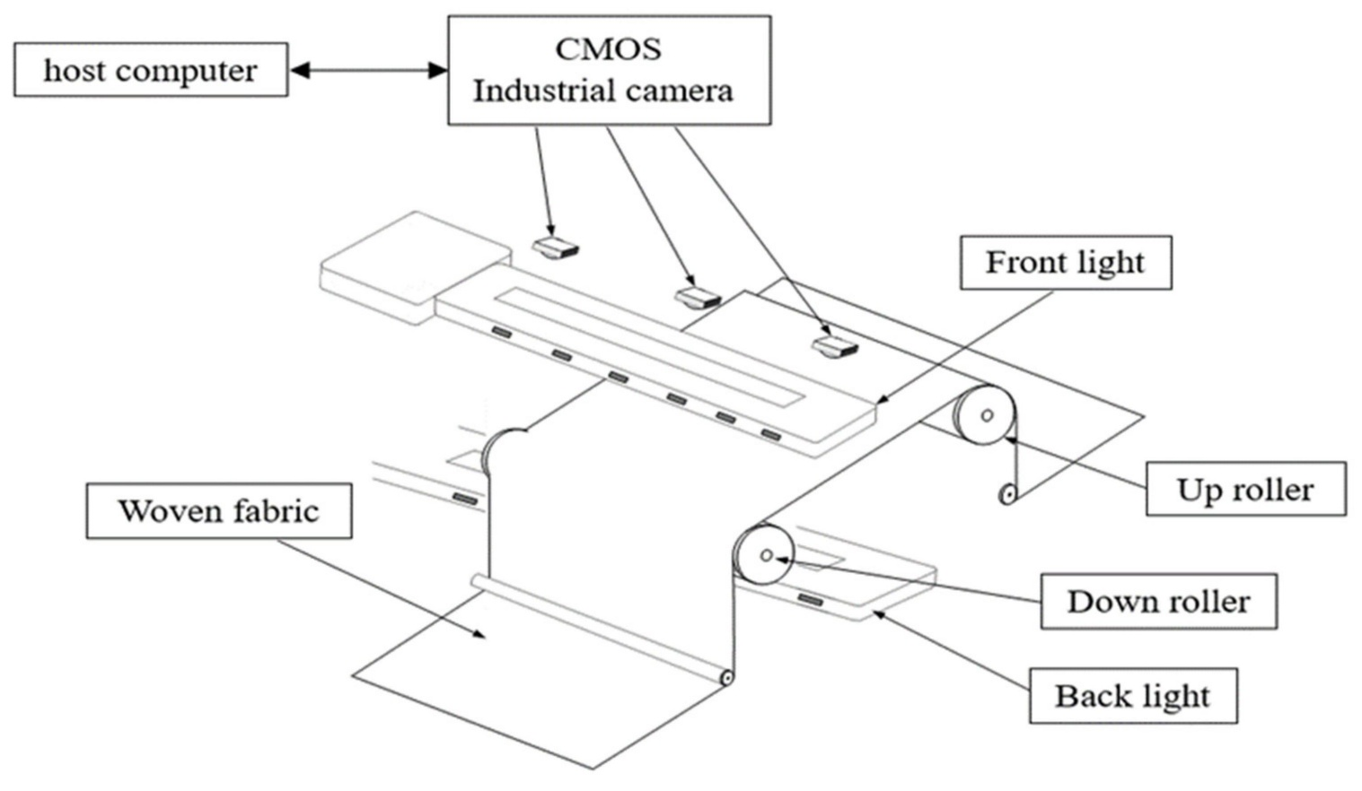

Industrial Camera
|
Camera Lens
|
Camera Height
700 mm
|
Reflected Light
|
-------------------------
Moving Cotton Fabric
-------------------------
|
Conveyor System
|
Captured Image
|
Image Processing
|
Width and Defect Detection
The camera must capture a clear and stable image to ensure accurate measurement and defect detection.

3. Perspective Distortion and Its Effect on Fabric-Width Measurement (Question 40)
Perspective distortion occurs when the camera views an object at an angle or when the camera and fabric are not positioned in the correct geometric arrangement. Objects at different positions may appear at different sizes in the captured image.
For example, if the camera is tilted, one side of the fabric may appear wider or narrower than the other side. This creates errors in fabric-width measurement.
Effects of perspective distortion:
- Incorrect fabric-width measurement.
- Unequal scaling across the image.
- Distorted fabric edges.
- Incorrect defect-location estimation.
- Reduced measurement accuracy.
For this project, the required width accuracy is ±2 mm. Therefore, perspective distortion must be minimized.
4. Camera Calibration and Measurement Accuracy (Question 41)
Camera calibration is the process of determining the camera's internal and external parameters to correct image distortion and establish the relationship between image pixels and real-world measurements.
Calibration helps identify:
- Focal length: Determines the camera's optical magnification.
- Principal point: The centre of the image projection.
- Lens distortion: Radial and tangential distortion caused by the lens.
- Camera position: The camera's orientation and position relative to the fabric.
A calibration pattern, such as a checkerboard, can be used to estimate these parameters. OpenCV provides camera-calibration functions to correct lens distortion.
Calibration process:
Capture Calibration Images
|
Detect Checkerboard
|
Calculate Camera
Parameters
|
Estimate Lens Distortion
|
Correct Distorted Image
|
Pixel-to-mm Conversion
|
Accurate Width Measurement
For a calibrated image, the approximate measurement is:
\[ \text{Real Width} = \text{Pixel Width}\times\text{mm per Pixel} \]
For example, assume the image scale is 0.5 mm/pixel and the fabric occupies 2,000 pixels:
\[ 2000 \times 0.5 = 1000\text{ mm} \]
Therefore, the measured fabric width is 1,000 mm.
Calibration improves measurement accuracy by correcting lens distortion and establishing a reliable pixel-to-millimetre scale. A fixed camera position and a reference scale or calibration target at the fabric plane are also necessary.
5. Effect of Lighting Variation from 500 to 3,000 Lux (Question 42)
Illumination plays an important role in defect visibility. In the textile industry, lighting variation can affect the contrast between normal fabric and defects.
The given lighting range is 500 to 3,000 lux.
Lighting condition | Effect on captured image
500 lux | Low illumination may make small defects difficult to identify.
1,000 lux | Moderate illumination can provide reasonable image visibility.
2,000 lux | Higher illumination may improve defect visibility if exposure is controlled.
3,000 lux | Excessive brightness may cause glare, saturation or loss of surface details.
Effects on different defects:
- Holes: May become difficult to identify under poor lighting.
- Broken threads: Require clear edge and texture visibility.
- Oil stains: Low contrast of only 5–8 grey levels makes lighting stability very important.
- Weaving irregularities: Uneven illumination may create false texture patterns.
- Colour variations: Changes in light intensity can affect colour measurements.
Therefore, controlled LED illumination should be used to maintain consistent brightness and improve defect detection.

6. Comparison of Three Image Formation Approaches
Feature | Standard perspective without calibration | Calibrated imaging with geometric correction | Controlled illumination with calibration
Image quality | May contain distortion | Corrected geometry | Corrected geometry and stable brightness
Width measurement | Less reliable | More accurate | More reliable
Lens distortion | Not corrected | Corrected | Corrected
Lighting variation | Not controlled | Not necessarily controlled | Controlled
Defect visibility | May vary | Improved geometric accuracy | Improved and consistent
Suitability | Low | Good | Best

7. Recommended Image Formation and Illumination Arrangement (Question 43)
Recommended approach
Controlled-illumination imaging with suitable calibration
This approach is recommended because the textile inspection system requires width accuracy of ±2 mm and must detect small defects of 1.5 mm.
Recommended arrangement:
- Mount the camera vertically at a fixed height of 700 mm.
- Use a suitable industrial lens to capture the complete 1,200 mm field of view.
- Use uniform LED lighting with a diffuser to reduce shadows and reflections.
- Calibrate the camera using a checkerboard calibration pattern.
- Apply geometric correction to remove lens distortion.
- Use a reference measurement at the fabric plane to establish the pixel-to-mm scale.
- Use OpenCV to measure fabric edges and detect defects.
- Maintain fixed exposure, gain and lighting during inspection.
Width measurement accuracy calculation:
Assume the horizontal image resolution is 2,448 pixels and the field of view is 1,200 mm.
$$\text{Pixel Scale}=\frac{1200}{2448} \\ =0.4902\text{ mm/pixel}$$
For the required ±2 mm accuracy:
$$\text{Pixel Error}=\frac{2}{0.4902}$$
$$≈4.08\text{ pixels}$$

Therefore, the total measurement error must be maintained within approximately ±4 pixels.
This is a sampling-based estimate, not a guarantee of measurement accuracy. Lens distortion, camera alignment, edge detection, calibration and fabric movement must also be tested to confirm the ±2 mm requirement.
Final arrangement:
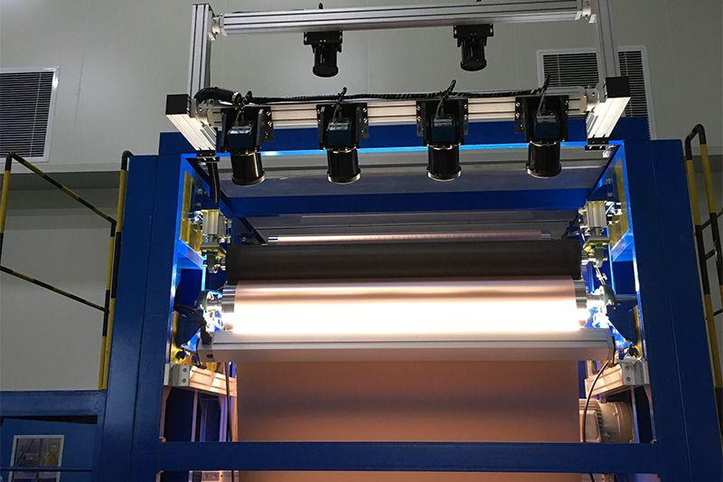
Industrial Camera
(700 mm)
|
Calibrated Lens
|
Uniform LED Lighting
|
Moving Fabric
|
Image Acquisition
|
Geometric Correction
|
Width Measurement
|
Defect Detection
|
Marking System
8. Conclusion
Image formation and calibration are important for accurate textile inspection. Standard perspective imaging without calibration may produce measurement errors due to lens and perspective distortion. Calibrated imaging improves geometric accuracy, while controlled illumination improves defect visibility and image consistency. Therefore, controlled-illumination imaging with suitable camera calibration is the best approach for Sri Lakshmi Textile Industries to achieve the required ±2 mm width accuracy and reliable defect detection.
.
TASK 9: Implementation and Performance Evaluation

1. Introduction
The proposed computer vision system is designed for Sri Lakshmi Textile Industries to inspect moving cotton and cotton-polyester fabric. The system detects holes, broken threads, oil stains and weaving irregularities, measures fabric width and sends defect-location information to a marking mechanism.
Three implementation configurations are considered:
- Budget configuration: Minimum-cost camera, basic illumination and CPU-based processing.
- Balanced configuration: Suitable industrial camera, controlled illumination and optimized CPU-based processing.
- Premium configuration: High-resolution industrial camera, advanced illumination and high-performance processing hardware.
The system must satisfy the following requirements:
- Fabric width: 1,000 mm.
- Smallest defect: 1.5 mm.
- Conveyor speed: 0.6 m/s.
- Maximum decision time: 0.5 seconds.
- Camera-to-marker distance: 0.3 m.
- Maximum missed-defect rate: 2%.
- Image retention: 7 days.
- Available budget: ₹1,50,000.
2. System Block Diagram (Question 44)
The system contains six major components: camera, illumination, processing unit, storage, network and marking mechanism.
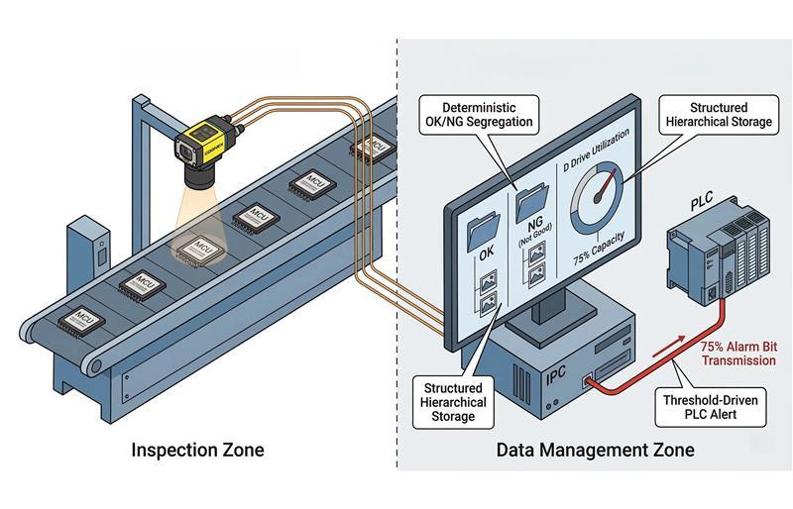
Block diagram:
Moving Fabric on Conveyor
|
v
Controlled LED Lighting
|
v
Industrial Camera
|
Image Acquisition
|
v
Processing Unit (CPU)
|
Image Processing using OpenCV
|
Defect Detection and Classification
|
Defect Location Calculation
|
+--------+--------+
| |
v v
Storage Gigabit Network
(7-day records) |
v
PLC / Controller
|
v
Marking Mechanism
|
v
Defect Marked on Fabric
Working process:
- LED lighting illuminates the moving fabric.
- The camera captures fabric images.
- The processing unit analyses the images using Python, OpenCV and NumPy.
- Detected defects are classified and their locations are calculated.
- Defect images and information are saved in storage.
- The location information is transmitted through the network to the PLC.
- The PLC activates the marking mechanism at the correct fabric position.
3. Comparison of Three Implementation Configurations (Question 45)
The three configurations are compared based on cost, camera resolution, processing time, storage and inspection capability.
A. Budget configuration
- Uses a low-cost USB or basic industrial camera.
- Uses simple LED illumination.
- Performs basic image processing using a CPU.
- Suitable for detecting larger holes and visible stains.
- May struggle to identify small defects of 1.5 mm.
B. Balanced configuration
- Uses a suitable 5 MP industrial camera.
- Uses uniform LED lighting with controlled exposure.
- Uses an optimized CPU with OpenCV and NumPy.
- Detects holes, broken threads, stains and weaving irregularities.
- Provides a practical balance between cost and performance.
C. Premium configuration
- Uses a high-resolution industrial camera.
- Uses advanced lighting and optical arrangements.
- Uses a high-performance processing system.
- Provides better image quality and processing capacity.
- Has a higher implementation and maintenance cost.
Configuration comparison table
Feature | Budget | Balanced | Premium
Camera | Basic camera | 5 MP industrial camera | High-resolution industrial camera
Resolution | 1280 × 1024 | 2448 × 2048 | 4096 × 3000
Illumination | Basic LED | Controlled LED with diffuser | Advanced multi-angle LED
Processing | Basic CPU | Optimized 4-core CPU | High-performance CPU/GPU
Estimated processing time | 0.4–0.8 s | 0.15–0.35 s | 0.05–0.15 s
Storage | 2 TB HDD | 2 TB storage | 2 TB or higher
Inspection capability | Basic | Good | Very high
Estimated cost | ₹85,000 | ₹1,45,000 | ₹2,50,000–₹3,50,000
Note: These are illustrative planning estimates, not verified supplier quotations. Actual performance depends on image size, algorithms, camera interface and computer specifications.
4. Defect Detection and Recording (Question 46)
The proposed system uses image processing techniques to identify different types of fabric defects. Images are captured by the camera and processed using Python, OpenCV and NumPy.
A. Hole detection
Holes are detected by identifying abnormal dark or bright regions in the fabric image. Thresholding and contour detection are used to identify their shape and location.
B. Broken-thread detection
Broken threads are detected by analysing the fabric's texture and edge patterns. Edge detection and morphological operations help identify discontinuities in thread structures.
C. Oil-stain detection
Oil stains are detected using colour and intensity differences. The image is converted from RGB/BGR to HSV or grayscale. Contrast enhancement using CLAHE helps identify stains with low contrast of 5–8 grey levels.
D. Weaving-irregularity detection
Weaving irregularities are identified by analysing repeated thread patterns and texture differences. Texture features and edge analysis help detect abnormal weaving structures.
Defect detection table
Defect type | Detection technique | Recorded information
Holes | Thresholding and contour detection | Size and position
Broken threads | Edge detection and texture analysis | Thread discontinuity and position
Oil stains | HSV analysis and CLAHE | Stain area and position
Weaving irregularities | Texture analysis and morphological operations | Irregularity type and location
Defect recording process:
Whenever a defect is identified, the system records:
- Defect identification number.
- Defect category.
- Horizontal and vertical location.
- Defect size.
- Date and time.
- Captured defect image.
- Inspection status.
This information is stored in the database or inspection log for future analysis and quality reporting.
5. Communication with the Marking Mechanism (Question 47)
The marking mechanism is installed 0.3 m downstream from the camera. The system must calculate the fabric movement and activate the marker when the detected defect reaches the marking position.
Given values:
- Camera-to-marker distance = 0.3 m.
- Conveyor speed = 0.6 m/s.
The time required for the fabric to travel from the camera to the marker is:
\[ T=\frac{\text{Distance}}{\text{Speed}} \]
\[ T=\frac{0.3}{0.6} \]
\[ \boxed{T=0.5\text{ seconds}} \]
Therefore, the defect reaches the marking mechanism after approximately 0.5 seconds, assuming constant conveyor speed.
Communication process:
Camera Captures Defect
|
v
Processing Unit Detects Defect
|
v
Calculate Defect Coordinates
|
v
Send Location to PLC
|
v
Encoder Tracks Fabric Movement
|
v
Defect Reaches Marker Position
|
v
PLC Activates Marker
|
v
Defect Marked on Fabric
The processing unit sends the defect coordinates to the PLC through a Gigabit Ethernet connection or a suitable industrial communication interface.
An encoder connected to the conveyor tracks fabric movement. The PLC activates the marker when the fabric has moved 300 mm from the detected defect position.
Important: Encoder-based tracking is more reliable than using a fixed 0.5-second timer because conveyor speed may change. The marking mechanism should also be tested for actuator response time and positioning accuracy.
6. Performance Evaluation of Three Configurations (Question 48)
The three configurations are evaluated against the required processing time, image retention and missed-defect rate.
A. Decision time
The maximum decision time is 0.5 seconds.
Configuration | Estimated processing time | Evaluation
Budget | 0.4–0.8 s | May fail
Balanced | 0.15–0.35 s | Expected to meet
Premium | 0.05–0.15 s | Expected to meet
The balanced and premium configurations are expected to meet the processing-time requirement if properly optimized and tested.
Since the marker is 0.3 m downstream, the total detection, communication and actuation delay must also fit within the 0.5-second travel time. Therefore, a processing target below 0.35 seconds is preferable.
B. Seven-day image retention
The system requires 7-day image retention. A 2 TB storage device can be used for storing inspection records, defect images and reports.
However, storing every full-resolution frame continuously may exceed 2 TB. Therefore, the system should use:
- Defect images and cropped regions for long-term retention.
- Compressed images to reduce storage requirements.
- Inspection metadata and defect reports.
- A temporary rolling buffer for recent full images.
- Automatic deletion of records older than seven days.
For example, if the system stores 10 MB of compressed defect images and records per minute:
\[ 10\times60\times24\times7 =100800\text{ MB} \]
\[ \boxed{\approx100.8\text{ GB}} \]
Thus, 2 TB storage is sufficient under this illustrative storage assumption. Actual storage requirements must be calculated using the measured defect frequency and image size.
C. Missed-defect rate
The maximum acceptable missed-defect rate is 2%.
\[ \text{Missed Defect Rate}= \frac{\text{Missed Defects}}{\text{Total Actual Defects}} \times100 \]
For example, if 1,000 actual defects are present and the system misses 15:
\[ \frac{15}{1000}\times100=1.5\% \]
The missed-defect rate is 1.5%, which satisfies the requirement.
Overall performance comparison
Requirement | Budget | Balanced | Premium
Decision time ≤ 0.5 s | Uncertain | Expected to meet | Expected to meet
Seven-day retention | Yes, with suitable storage policy | Yes, with suitable storage policy | Yes, with suitable storage policy
Missed-defect rate ≤ 2% | Difficult to guarantee | Achievable after validation | Achievable after validation
Small 1.5 mm defects | Limited capability | Suitable with proper optics | Better capability
Overall suitability | Low | High | Very high
Observation: The premium configuration offers better processing capacity, but it is expensive. The budget configuration is economical but may not reliably identify small defects. The balanced configuration provides a suitable compromise.
The 2% missed-defect target cannot be guaranteed from camera resolution or processing speed alone. It must be verified through testing with representative fabric samples, including low-contrast stains and small defects.
7. Recommended Configuration and Budget Justification (Question 49)
Selected configuration: Balanced
The balanced configuration is recommended because it provides suitable image quality, controlled illumination and optimized CPU-based processing while remaining within the available ₹1,50,000 budget.
Estimated cost breakdown
Component | Estimated cost
5 MP industrial camera | ₹35,000
Industrial lens | ₹10,000
Controlled LED lighting and diffuser | ₹12,000
4-core CPU processing computer with 16 GB RAM | ₹40,000
2 TB storage device | ₹8,000
Encoder and PLC/controller interface | ₹10,000
Defect marking mechanism | ₹12,000
Gigabit Ethernet, cables and connectors | ₹3,000
Mounting frame and protective enclosure | ₹5,000
Calibration and miscellaneous setup | ₹5,000
Total estimated cost | ₹1,40,000
Budget calculation
Available budget
₹1,50,000
Estimated implementation cost
₹1,40,000
Remaining amount
₹10,000
Assumptions used in cost estimation
- Prices are approximate planning estimates in Indian rupees, not supplier-confirmed prices.
- The balanced configuration uses an industrial camera with approximately 5 MP resolution.
- The processing computer uses a 4-core CPU and 16 GB RAM without a dedicated GPU.
- Existing conveyor infrastructure is available.
- The 2 TB storage device is sufficient when full-frame images are not stored continuously.
- Python, OpenCV and NumPy are open-source software and do not require paid software licences.
- Installation and major conveyor modifications are not included in the estimated cost.
Why the balanced configuration is selected
- It fits within the ₹1,50,000 budget.
- It provides better image quality than a basic camera.
- Controlled illumination improves visibility of low-contrast oil stains.
- Optimized CPU processing reduces implementation cost.
- Encoder-based tracking improves defect-marking accuracy.
- It supports seven-day image retention with an appropriate storage policy.
- It has the potential to achieve the required missed-defect rate of less than or equal to 2%, subject to validation.
8. Conclusion
The three configurations provide different levels of cost, processing performance and inspection capability. The budget configuration is economical but may not detect all small fabric defects reliably. The premium configuration offers high performance but exceeds the available budget. Therefore, the balanced configuration is the most suitable choice, with an estimated implementation cost of ₹1,40,000. It combines a 5 MP industrial camera, controlled LED illumination, optimized CPU processing, 2 TB storage and encoder-based marking. With proper calibration and performance testing, it can be designed to meet the required 0.5-second decision time, seven-day image retention and maximum 2% missed-defect rate.
TASK 10: Front-End Adaptation Challenge
Marks: 8 | Computer Vision – Assignment 2
1. Introduction
Sri Lakshmi Textile Industries receives a new export order with more demanding inspection requirements. The existing computer vision system must be adapted to detect smaller defects, identify stains under ultraviolet (UV) illumination, operate at a higher conveyor speed and inspect twice the current production volume.
The new requirements are:
Parameter | Existing system | New requirement
Smallest defect size | 1.5 mm | 0.4 mm
Conveyor speed | 0.6 m/s | 1.2 m/s
Inspection volume | Current volume | Twice the current volume
Decision time | 0.5 seconds | 0.3 seconds
UV stain detection | Not available | Required
Existing PC | 4-core CPU, 16 GB RAM | Unchanged
Project budget | ₹1,50,000 | Unchanged

Three adaptation strategies are considered:
- Retain the existing system with only software changes.
- Modify the existing system by upgrading selected components.
- Redesign the inspection system using a different acquisition and processing architecture.
2. Existing System Components That Become Inadequate (Question 50)
The existing system was designed for 1.5 mm defects and a conveyor speed of 0.6 m/s. The new requirements increase the inspection difficulty.
Existing component | Problem under new requirements | Required improvement
5 MP camera | May not provide sufficient pixels for 0.4 mm defects | Higher-resolution or suitable line-scan camera
Standard lens | May not provide sufficient optical detail | Suitable industrial lens with appropriate magnification
Normal LED lighting | Cannot identify UV-specific stains reliably | UV illumination
4-core CPU | May struggle with twice the image-processing workload | More efficient algorithms and hardware acceleration if available
Basic image processing | May miss very small defects | Improved sampling and detection algorithms
Existing acquisition rate | May not capture sufficient images at higher speed | Faster acquisition and encoder synchronization
Existing storage arrangement | Higher inspection volume increases data generation | Optimized compression and defect-only storage
Marking arrangement | Higher speed reduces available marking time | Faster PLC communication and encoder-based tracking
Observation: The camera, lens, illumination and acquisition arrangement are the main components that require improvement. The existing PC is a major processing limitation because it cannot be upgraded under the given conditions.
3. Effect of Increased Conveyor Speed and Smaller Defect Size on Image Sampling and Acquisition (Question 51)
The new system must detect defects as small as 0.4 mm while the conveyor operates at 1.2 m/s.
A. Effect of smaller defect size
The existing system was designed for a minimum defect size of 1.5 mm. The new requirement is 0.4 mm.
Assume that a defect should cover at least 4 pixels for reliable identification.
\[ \text{Required pixel scale}= \frac{\text{Defect size}}{\text{Number of pixels}} \]
\[ =\frac{0.4}{4} \]
\[ \boxed{0.1\text{ mm/pixel}} \]
Therefore, the system should achieve approximately 0.1 mm/pixel or finer spatial sampling.
For a horizontal field of view of 1,200 mm:
\[ \text{Required horizontal resolution} =\frac{1200}{0.1} \]
\[ \boxed{12000\text{ pixels}} \]
This indicates that approximately 12,000 pixels across the fabric are required to obtain four pixels across a 0.4 mm defect.
B. Effect of increased conveyor speed
The existing conveyor speed is 0.6 m/s, while the new speed is 1.2 m/s.
\[ \text{Speed increase}=\frac{1.2}{0.6}=2 \]
Therefore, the fabric moves twice as fast as before.
For a line-scan camera, assuming a vertical sampling interval of 0.1 mm:
\[ \text{Line rate}= \frac{\text{Conveyor speed}}{\text{Sampling interval}} \]
\[ =\frac{1200\text{ mm/s}}{0.1\text{ mm}} \]
\[ \boxed{12000\text{ lines/second}} \]
The camera must capture at least 12,000 lines per second to maintain 0.1 mm sampling in the direction of fabric movement.
C. Motion blur calculation
Assume that the maximum acceptable motion blur is 20% of the smallest defect.
\[ \text{Maximum blur}=0.4\times0.2 \]
\[ =0.08\text{ mm} \]
Maximum exposure time:
\[ T=\frac{0.08}{1200} \]
\[ \boxed{T=0.0000667\text{ seconds}} \]
\[ \boxed{T\approx66.7\text{ microseconds}} \]
Therefore, a short exposure time of approximately 67 microseconds or less is required under this assumption.
Observation: A higher-resolution camera, faster acquisition rate and short exposure time are necessary to detect 0.4 mm defects without motion blur.
4. Role of UV Illumination and Additional Imaging Channel (Question 52)
Ultraviolet illumination helps identify stains that may not be clearly visible under normal white light. Certain materials absorb UV light and emit visible fluorescence, while others show different reflectance characteristics under UV illumination.
The system can use an additional UV imaging channel along with the normal visible-light camera.

Working process:
- Normal LED lighting captures the fabric's ordinary appearance.
- UV illumination is directed towards the fabric.
- A suitable camera sensor and optical filter capture the UV-induced response.
- The visible-light and UV images are analysed separately.
- The processing unit compares the images to identify unusual stain regions.
- The system records the stain location and sends the information to the marking mechanism.
UV imaging arrangement:
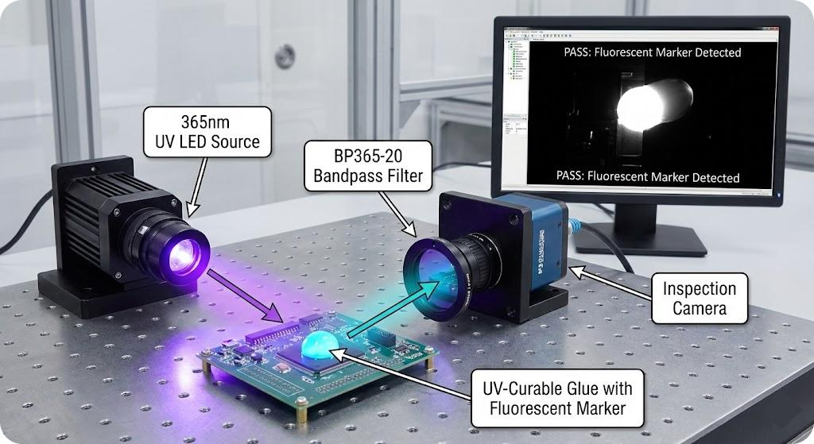Comparison of imaging channels:
Feature | Normal visible-light imaging | UV imaging
Light source | White LED | UV LED
Main purpose | Normal fabric and visible defects | UV-responsive stains
Hole detection | Suitable | May provide additional information
Oil-stain detection | Depends on colour and contrast | Can reveal fluorescence or UV response
Colour variation | Suitable | Not a replacement for visible colour imaging

A UV-sensitive camera or a suitable UV-compatible optical arrangement is necessary. A normal camera cannot automatically identify all UV-responsive stains.
Recommended approach: Use normal visible-light imaging for general defect detection and an additional UV channel for special stain detection. UV illumination must be enclosed and shielded to protect operators.
5. Comparison of Three Adaptation Strategies (Question 53)
A. Strategy 1: Retain the existing system with software changes
In this approach, the existing camera, lighting and computer remain unchanged. Only the image-processing algorithms are improved.
- Optimize OpenCV operations.
- Use image cropping and region-of-interest processing.
- Apply improved thresholding and texture analysis.
- Compress and store only defect images.
Advantages: Low cost and easy implementation.
Limitations: Existing camera resolution and normal lighting cannot reliably meet the new 0.4 mm and UV requirements.
B. Strategy 2: Upgrade selected components
In this approach, the existing architecture is retained, but selected components are upgraded.
- Install a higher-resolution camera.
- Use a suitable industrial lens.
- Add UV LED illumination and an additional imaging channel.
- Introduce encoder synchronization.
- Optimize CPU-based processing.
- Use compressed defect-image storage.
Advantages: Improves image quality and defect visibility without replacing the entire system.
Limitations: The existing PC may become a bottleneck when processing high-resolution images from two imaging channels.
C. Strategy 3: Redesign using a different architecture
This approach uses a new acquisition and processing architecture.
- High-speed line-scan camera.
- High-resolution image acquisition.
- Normal and UV illumination channels.
- Encoder-based fabric tracking.
- Parallel or hardware-accelerated image processing.
- High-speed storage and communication.
Advantages: Best potential for high-speed and small-defect inspection.
Limitations: Expensive, complex and likely to require additional processing hardware and budget.
Overall comparison table
Evaluation factor | Strategy 1: Software only | Strategy 2: Selected upgrades | Strategy 3: Full redesign
Feasibility | Low | Moderate to high | Low under current constraints
Accuracy | Limited | Improved | Highest potential
Processing time | May exceed 0.3 s | Can be optimized | Best potential
Cost | Very low | Moderate | Very high
UV detection | Not available with existing setup | Possible | Fully integrated
Small-defect detection | Difficult | Improved with suitable camera | Best potential
Implementation risk | Medium | Medium | High
Suitability | Poor | Best practical compromise | Requires additional resources
6. Recommended Adaptation Strategy (Question 54)
Recommended: Strategy 2 – Upgrade selected components
The most practical strategy is to modify the existing system by upgrading selected components.
This approach is suitable because the existing PC and total budget must remain unchanged. A complete redesign would require additional processing hardware and a higher investment.
Recommended improvements:
- Replace the existing camera with a suitable high-resolution industrial camera or line-scan camera.
- Install a suitable industrial lens to achieve the required 0.1 mm/pixel sampling.
- Add UV LED illumination and a suitable UV imaging channel.
- Use an encoder to synchronize image acquisition with conveyor movement.
- Optimize OpenCV algorithms to reduce CPU processing time.
- Use region-of-interest processing to avoid analysing unnecessary image areas.
- Store compressed defect images instead of every full-resolution frame.
However, the 0.3-second decision time and twice-volume requirement must be verified through actual CPU benchmarking. If the existing PC cannot handle the required image throughput, these targets cannot be guaranteed without additional processing resources.
7. Updated System Block Diagram and Required Changes (Question 55)
The updated system combines normal imaging and UV imaging to inspect the fabric under different illumination conditions.
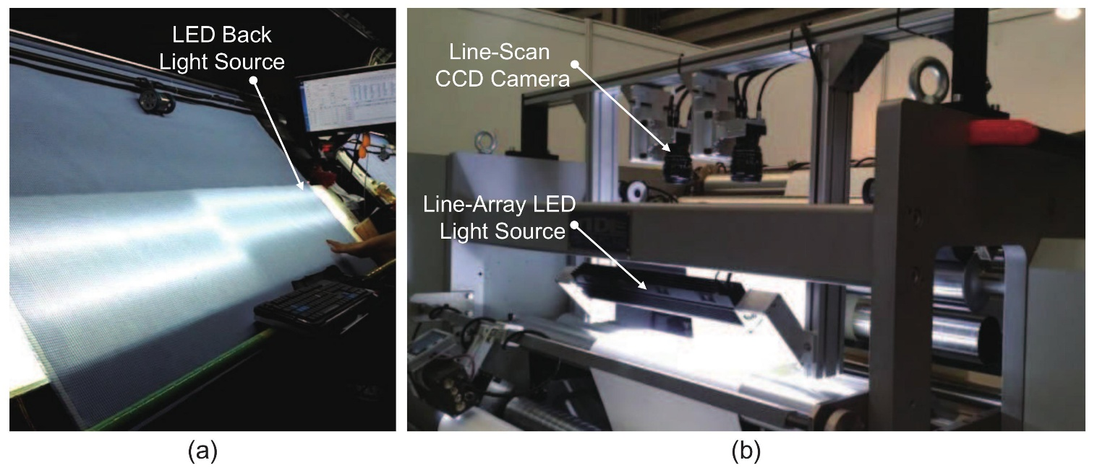Updated block diagram:
Moving Fabric
|
Conveyor Encoder
|
+-------+-------+
| |
v v
Normal LED UV LED
Illumination Illumination
| |
v v
Visible Camera UV Imaging Channel
| |
+-------+-------+
|
v
Image Acquisition
|
v
Optimized CPU Processing
(Python + OpenCV)
|
v
Image Preprocessing and
Defect Detection
|
v
Visible and UV Image
Analysis
|
v
Defect Classification
and Localization
|
+-------+-------+
| |
v v
Storage Gigabit Network
(Defect Images) |
v
PLC Controller
|
v
Marking Mechanism
List of required changes
Component | Required change | Purpose
Camera | Upgrade to suitable high-resolution camera | Detect 0.4 mm defects
Lens | Use suitable industrial lens | Improve image detail
Lighting | Add UV LED lighting | Identify UV-responsive stains
Imaging channel | Add UV-sensitive camera or suitable UV channel | Capture UV response
Acquisition | Use encoder synchronization | Handle 1.2 m/s movement
Processing | Optimize CPU algorithms | Reduce processing time
Software | Add visible and UV image analysis | Detect different defect types
Storage | Use compression and defect-only recording | Support increased production volume
Network | Improve PLC communication and synchronization | Faster marking control
Marking | Verify actuator response at higher speed | Mark defects accurately
8. Requirements That Cannot Realistically Be Achieved Without Additional Resources (Question 56)
Although selected component upgrades can improve the existing system, some requirements may not be achievable under the unchanged PC and budget constraints.
New requirement | Can it be achieved? | Reason
Detect 0.4 mm defects | Possible with suitable camera and optics | Requires approximately 0.1 mm/pixel sampling under the four-pixel assumption
UV stain detection | Possible | Requires UV lighting and a suitable imaging channel
Conveyor speed of 1.2 m/s | Possible with faster acquisition | Requires high-speed camera and encoder synchronization
Twice the production volume | Uncertain | Requires increased acquisition and processing throughput
Decision within 0.3 seconds | Not guaranteed | Existing 4-core CPU may become overloaded
Maximum 2% missed-defect rate | Not guaranteed | Requires representative testing and sufficient image quality
Existing PC and budget unchanged | Must be maintained | Limits the available hardware upgrades
Important limitations:
- A 12,000-pixel-wide image with a 12,000-line-per-second acquisition rate can generate a very large data stream.
- Two imaging channels increase processing and storage requirements.
- The existing 4-core CPU and 16 GB RAM may not support all high-resolution processing tasks within 0.3 seconds.
- A high-speed marking mechanism may also be necessary to operate reliably at the increased conveyor speed.
- UV imaging requires suitable sensors, filters and safe lighting arrangements.
Therefore, additional processing hardware, increased storage bandwidth or a larger budget may be necessary to guarantee all new requirements simultaneously.
9. Final Conclusion
The new export order requires significant improvements in image acquisition, illumination, processing and defect detection. Software-only changes are insufficient because the existing camera and lighting system were designed for larger defects and normal visible-light inspection. A complete redesign provides the best technical performance but is expensive and unsuitable under the unchanged budget and PC constraints.
Therefore, upgrading selected components is the most practical adaptation strategy. A higher-resolution camera, suitable lens, UV illumination, encoder synchronization and optimized CPU processing can improve the inspection system. However, detecting 0.4 mm defects, processing twice the production volume and meeting the 0.3-second decision time simultaneously cannot be guaranteed without testing.

